Name: ____________________________ Surname: ____________________________ N^{ber}: ____ Grade/Class: _____
Assessment: _____________________________ | Date: ___________________________________________________
 | Teacher’s signature:  ___________________________ | Parent’s signature:  ___________________________

- Look at the pictures and complete the missing letters.

He doesn’t like p__________ c__________ g_________.
He hates p__________ the g___________.
They like p__________ t___________.
He likes p_____________.
They love r________ b______.
They like p__________ c__________.
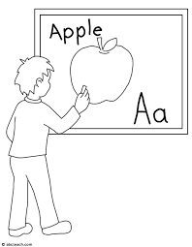
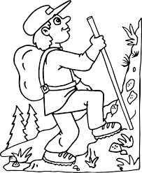
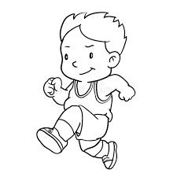
He loves l__________ E__________.
He likes h__________.

He hates r__________.

Answer key

He doesn’t like playing computer games.
He hates playing the guitar.
They like playing tennis.
He likes painting.
They love riding a bike.
They like playing chess.
He loves learning English.
He likes hiking.

He hates running.

