Name: ____________________________ Surname: ____________________________ N^{ber}: ____ Grade/Class: _____
Assessment: _____________________________ | Date: ___________________________________________________
 | Teacher’s signature:  ___________________________ | Parent’s signature:  ___________________________
1.Choose the correct option.
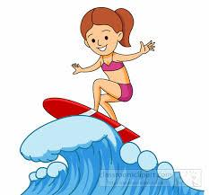  - dancing  - surfing  - swimming | 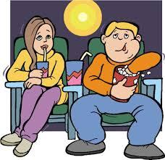  - going to the cinema  - taking a photo  - walking | 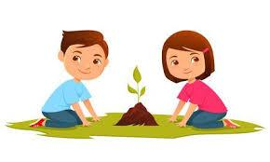  - running  - playing soccer  - gardening | 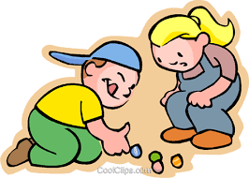  - playing marbles  - playing hangman  - drawing a picture
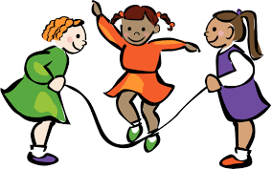  - skipping a rope  - sleeping  - studying | - writing  - reading comics  - hula hoop | 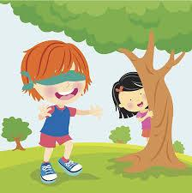  - playing hide and seek  - flying a kite  - playing tennis | - reading  - coloring books  - writing
- playing the piano  - playing the violin  - playing marbles | - fishing  - horse riding  - yoyo | - listening to music  - playing bowling  - ice-skating | 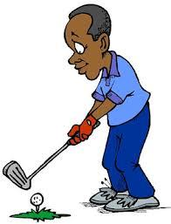  - hunting  - playing golf  - sailing
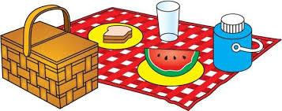  - going to a picnic  - going to concerts  - visiting museums | 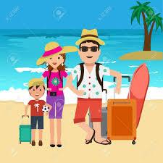  - gardening  - rowing  - going to the beach | - swimming  - knitting  - skating | 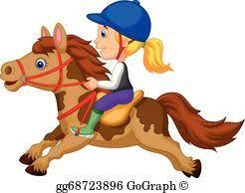  - hunting  - horse riding  - bike riding

Answer key
surfing | going to the cinema | gardening | playing marbles
skipping a rope | hula hoop | playing hide and seek | coloring books
playing the violin | yoyo | ice-skating | playing golf
going to a picnic | going to the beach | knitting | horse riding

