Name: ____________________________ Surname: ____________________________ N^{ber}: ____ Grade/Class: _____
Assessment: _____________________________ | Date: ___________________________________________________
 | Teacher’s signature:  ___________________________ | Parent’s signature:  ___________________________
- Unscramble the words and write under the correct picture.
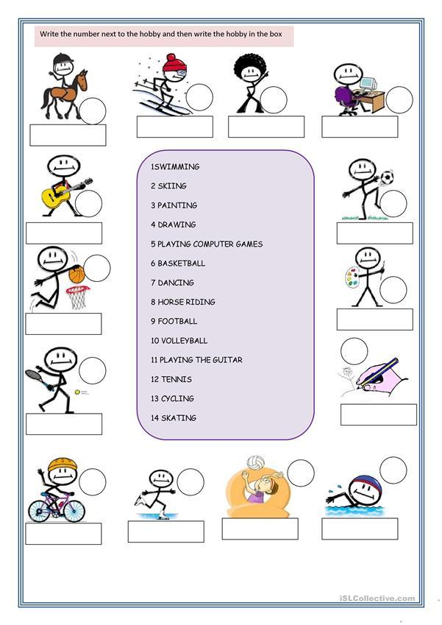
1. MSIWINMG
2. LPAYNGI BALLEYVOLL
3. NGIIKS
4. TINGPAIN
5. WRADNGI
6. NCIGNDA
7. LPANGIY NETNIS
8. OHRSE IDNGRI
9. KIBE RINGID
10. LPAIGNY FOLBLATO
11. SINGKTA
12. PLANYIG COPMURET MAGES
13. PYALNIG KASBETLABL
14. PAYLGIN TEH GIURAT
Answer key
1. swımmıng
2. playıng volleyball
3. skiing
4. painting
5. drawing
6. dancing
7. playing tennis
8. horse riding
9. bike riding
10. playing football
11. skatıng
12. playing computer games
13. playing basketball
14. playing the guitar

