Name: ____________________________ Surname: ____________________________ N^{ber}: ____ Grade/Class: _____
Assessment: _____________________________  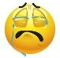 | Date: ___________________________________________________
 | Teacher’s signature:  ___________________________ | Parent’s signature:  ___________________________

- Complete the sentences with the correct hobby.

- I love the sea and sun. My favorite hobby is _____________.
- I love books. My favorite hobby is _____________.
- I love rap, pop, rock. My favorite hobby is _____________.
- I like eating and food. My favorite hobby is _____________.
- I go to a disco every week. My favorite hobby is _____________.
- I have got a digital camera. My favorite hobby is _____________.
- I like going to shops and new clothes. My favorite hobby is _____________.
- I like visiting websites. My favorite hobby is _____________.
- I like films. My favorite hobby is _____________.
- I love songs. My favorite hobby is _____________.
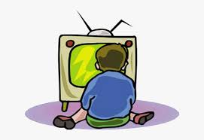
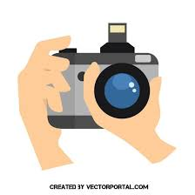
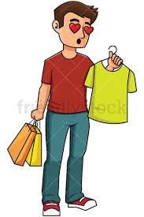
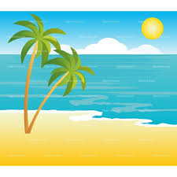
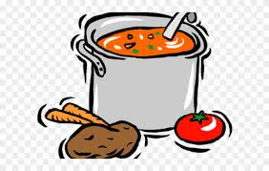
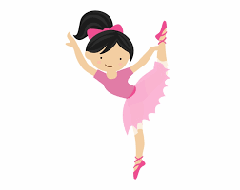

Answer key

- I love the sea and sun. My favorite hobby is going to the beach / swimming.
- I love books. My favorite hobby is reading.
- I love rap, pop, rock. My favorite hobby is listening to music.
- I like eating and food. My favorite hobby is cooking.
- I go to a disco every week. My favorite hobby is dancing.
- I have got a digital camera. My favorite hobby is taking photos.
- I like going to shops and new clothes. My favorite hobby is shoppings.
- I like visiting websites. My favorite hobby is surfing the net.
- I like films. My favorite hobby is watching TV / watching films / going to the cinema.
- I love songs. My favorite hobby is singing.

