Name: ____________________________ Surname: ____________________________ N^{ber}: ____ Grade/Class: _____
Assessment: _____________________________ | Date: ___________________________________________________
 | Teacher’s signature:  ___________________________ | Parent’s signature:  ___________________________
- What is Garfield doing?
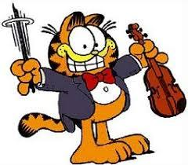
______________________________________ ______________________________________

______________________________________ ______________________________________

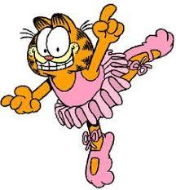
______________________________________ ______________________________________

______________________________________ ______________________________________

Answer key
He is playing the violin
He is reading a book
He is playing basketball
He is flying a kite
He is playing football
He is dancing
He is drawing
He is playing tennis

