Name: ____________________________ Surname: ____________________________ N^{ber}: ____ Grade/Class: _____
Assessment: _____________________________ | Date: ___________________________________________________
 | Teacher’s signature:  ___________________________ | Parent’s signature:  ___________________________

- Write about the activities you like and you don’t like.
- __________________________.

☹ __________________________.

- Write the activities and answer the questions.
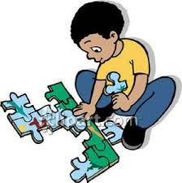
Does he like doing puzzle?
___________________.
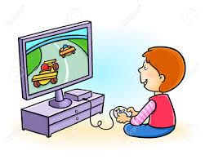
Does he like ....................................?
___________________.
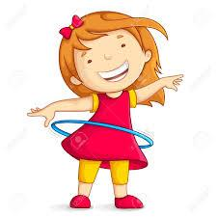
Does she like ....................................?
___________________.

Does she like ....................................?
___________________.
Does he like ....................................?
___________________.
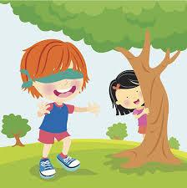

Answer key

- Write the activities and answer the questions.

Does he like doing puzzle?
_Yes, he likes doing puzzle_____.
Does he like playing computer games?
_No, he doesn’t like playing c.games.
Does she like playing hula hoop?
_Yes, she likes playing hula hoop_.

Does she like listening to music?
No, she doesn’tlike listening to music.

Does he like playing hide and seek?
No, he doesn’tlike playing hide and seek.

