Name: ____________________________ Surname: ____________________________ N^{ber}: ____ Grade/Class: _____
Assessment: _____________________________ | Date: ___________________________________________________
 | Teacher’s signature:  ___________________________ | Parent’s signature:  ___________________________

- Look and write the sentences.
+ dislike + 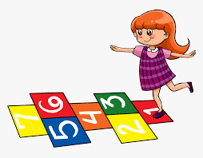=

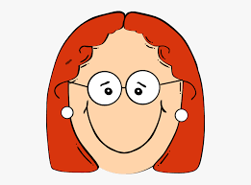+ love + 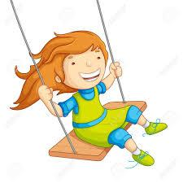=

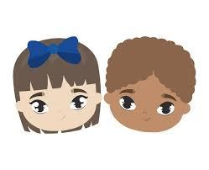+ hate + 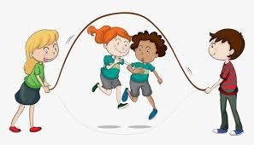=

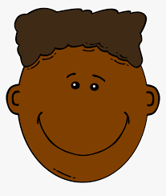+ like + 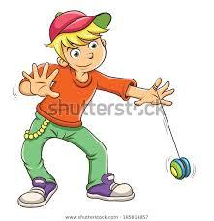=

+ doesn’t like + 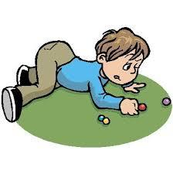=

Answer key

She dislikes playing hopscotch.
She loves swinging.
They hate skipping a rope.
He likes yoyo.
He doesn’t like playing marbles.

