Name: ____________________________ Surname: ____________________________ N^{ber}: ____ Grade/Class: _____
Assessment: _____________________________  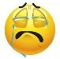  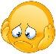  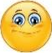 | Date: ___________________________________________________
 | Teacher’s signature:  ___________________________ | Parent’s signature:  ___________________________

- Look at the pictures and write what they are doing.
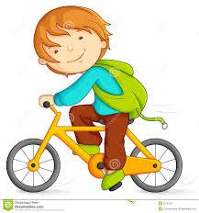
He is ________________________.
________________________________.
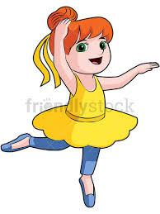
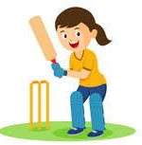
_______________________________.

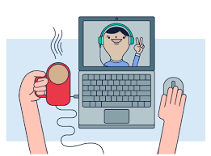
______________________________.
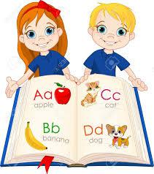
______________________________.

Answer key

He is riding a bike.
She is dancing.
She is playing cricket.
He is video calling.
They are learning English.

