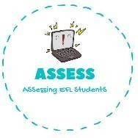
ENGLISH WORKSHEET

TOPIC: At home | SUBTOPICS: Bedroom | LEVEL: A2
Name: Surname: N^{ber}: Grade/Class:

- Hey, it's your turn to the bed. make / do / sleep

- Can you close the , the neighbors can see everything. sheets / curtains / door

- Can you get me another , it's going to be a cold night. blanket / pillow / pillow case

- A pillow is something you put on your pillow so it won't get dirty. sheet / frame / case

- You're going to bed already? OK, pleasant ! thoughts / sleep / dreams

- I need to wake up very early. Could you set the for 6 AM? clock / alarm / ring

- Please hang your clothes in the , and don't leave them on the floor. bed / closet / shelf

- My girlfriend has cute pink that she likes to wear around the house. blouse / shirt /slippers

- I haven't worn since I was a kid. ties / pyjamas / curtains

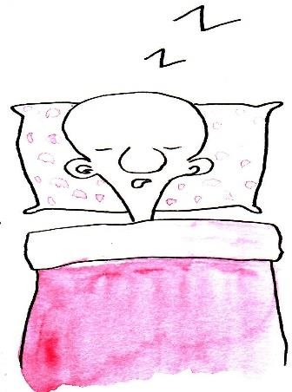
- I can't sleep in the same room as my grandfather, he very loudly. sleeps / snores / talks

Assessing EFL Students

