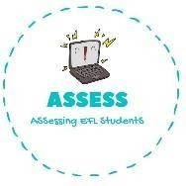
ENGLISH WORKSHEET

TOPIC: In the house | SUBTOPICS: Categories exercise | LEVEL: A2
Name: Surname: N^{ber}: Grade/Class:

plate / curtain / desk / knife / laptop / door / bowl / cushions / mug / chair / blanket / jug / frying pan / fork / glass / armchair

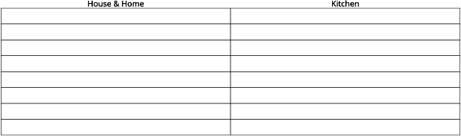

Assessing EFL Students

