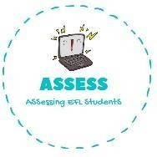
ENGLISH WORKSHEET

TOPIC: In the house | SUBTOPICS: Multiple choice | LEVEL: A2
Name: Surname: N^{ber}: Grade/Class:

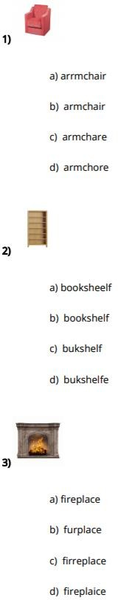
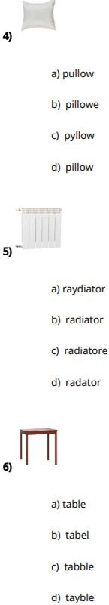
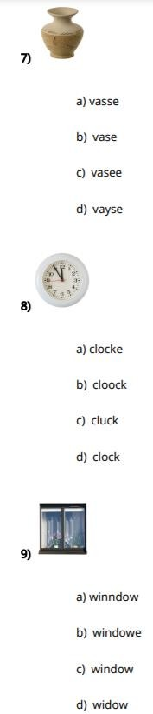
Assessing EFL Students

