Name: ____________________________ Surname: ____________________________ N^{ber}: ____ Grade/Class: _____
Assessment: _____________________________ | Date: ___________________________________________________
 | Teacher’s signature:  ___________________________ | Parent’s signature:  ___________________________

Listen and color according to the instructions.
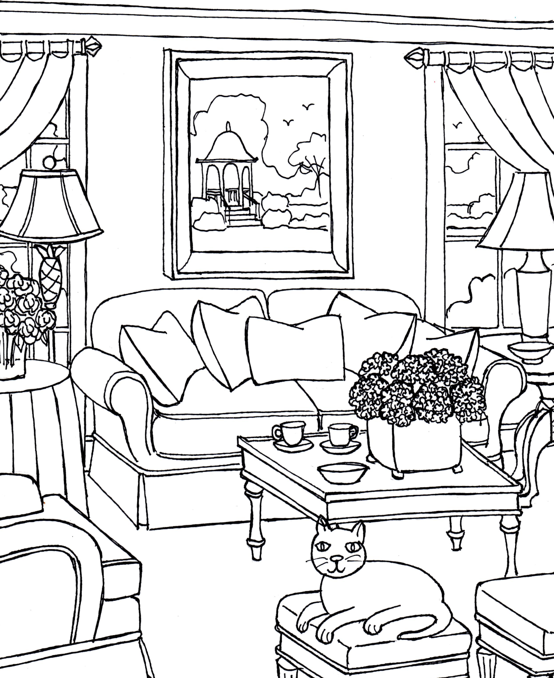

Color the sofa blue.
Color the curtains yellow.
Color the cat grey.
Color the table black.
Color the cushions orange.
Color the cups pink.
Color the lamps purple.
Color the cups red.

