Name: ____________________________ Surname: ____________________________ N^{ber}: ____ Grade/Class: _____
Assessment: _____________________________ | Date: ___________________________________________________
 | Teacher’s signature:  ___________________________ | Parent’s signature:  ___________________________

- Listen and circle the correct answer about things in the dining room.
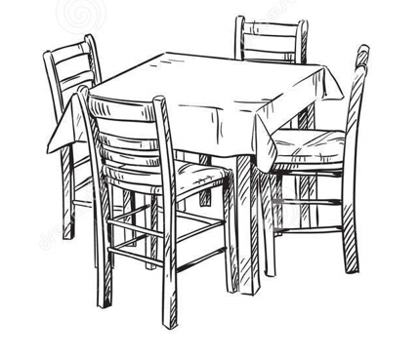

What color is the table? White Blue Brown

What color are the chairs? Brown White Black

What is on the table? A blue tablecloth A red tablecloth A brown tablecloth

What do we do in the dining room? We eat dinner We eat breakfast We eat lunch

- Colour the furniture according to instructions.

Transcript 1:
There is a brown table in the dining room.
The chairs are black.
On the table there is a red tablecloth.
We eat breakfast in the dining room.

Transcript 2:
Colour the chairs black.
Colour the table brown.
Colour the tablecloth red.

