Name: ____________________________ Surname: ____________________________ N^{ber}: ____ Grade/Class: _____
Assessment: _____________________________ | Date: ___________________________________________________
 | Teacher’s signature:  ___________________________ | Parent’s signature:  ___________________________

Listen and follow the instructions.

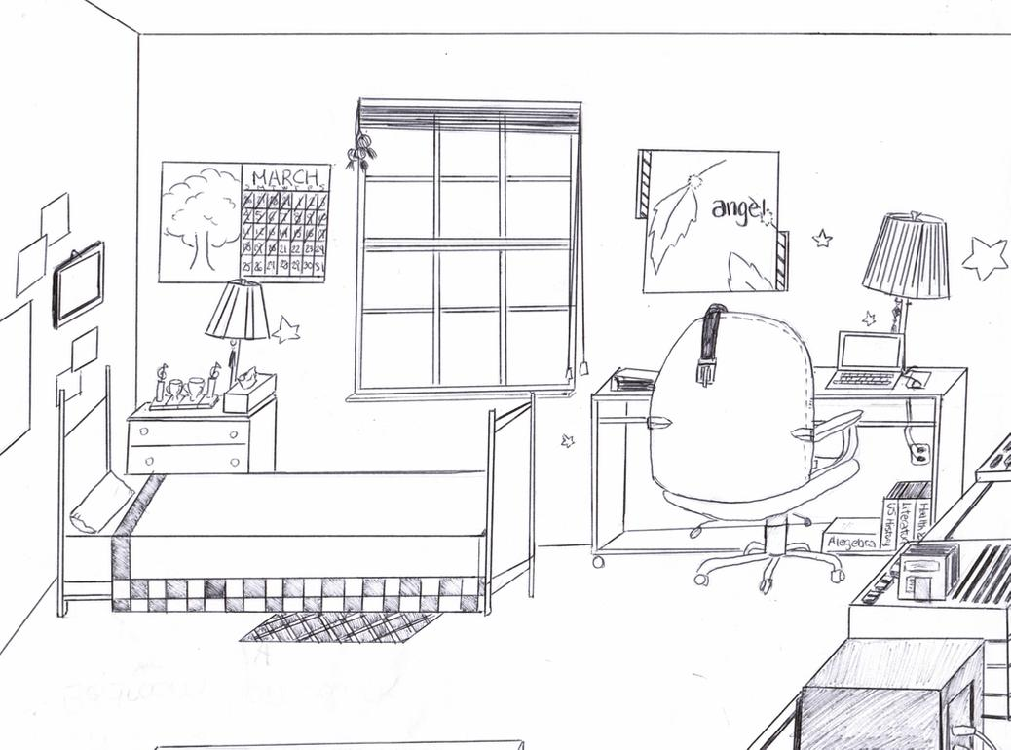

Transcript:

Circle the chair.
Color both lamps yellow.
Put a red dot on the both lamps.
Put a cross over the bed.
Color the cushion green.
Draw a line over the calendar.
Color the window blue.
Draw a triangle around the computer.
Color all the stars red.

