Name: ____________________________ Surname: ____________________________ N^{ber}: ____ Grade/Class: _____
Assessment: _____________________________ | Date: ___________________________________________________
 | Teacher’s signature:  ___________________________ | Parent’s signature:  ___________________________
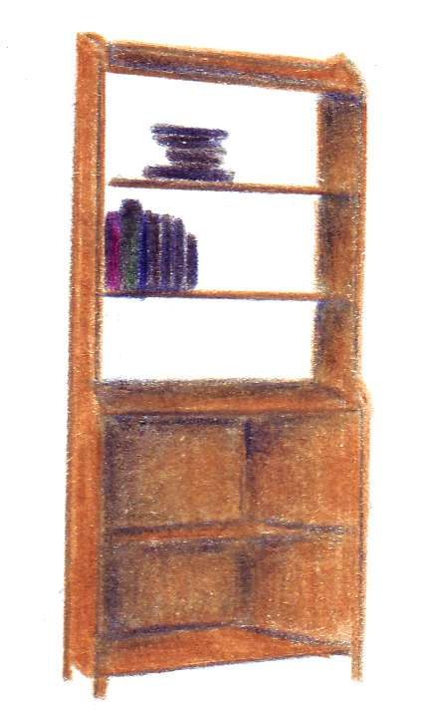
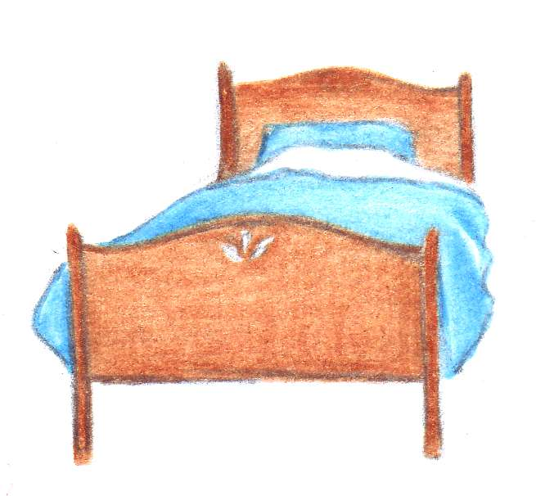
Listen and add the correct numbers from 1 to 9 in the boxes.

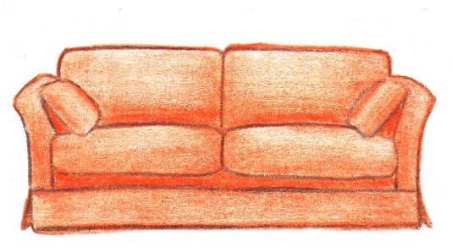
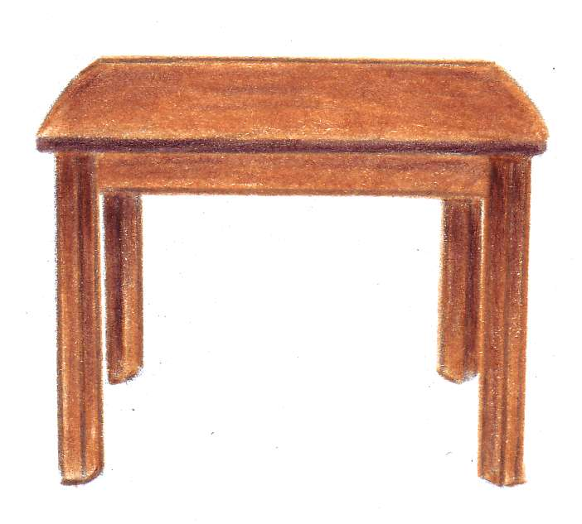
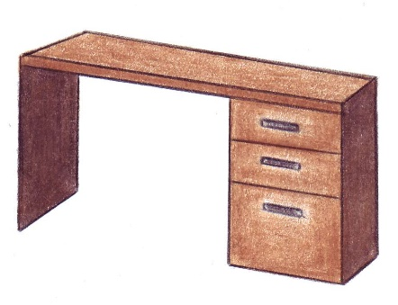

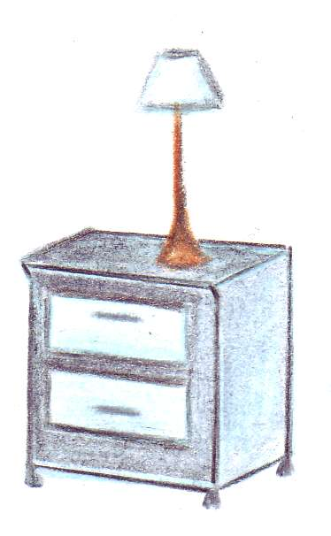
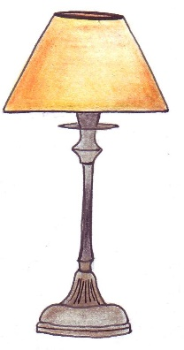
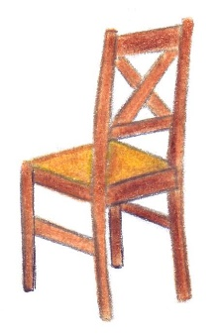

Transcript:
- A sofa
- A rug
- A bed
- A lamp
- A desk
- A bedside table
- A chair
- A bookkcase
- A table

