Name: ____________________________ Surname: ____________________________ N^{ber}: ____ Grade/Class: _____
Assessment: _____________________________ | Date: ___________________________________________________
 | Teacher’s signature:  ___________________________ | Parent’s signature:  ___________________________

Listen and write the correct number in the box
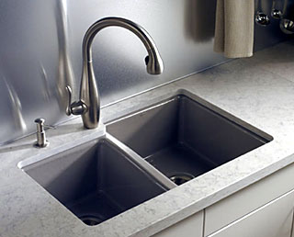
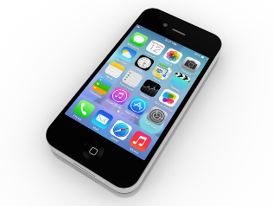
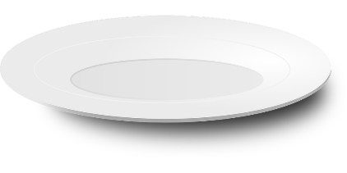

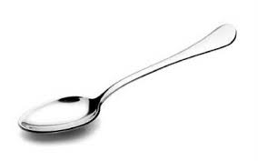
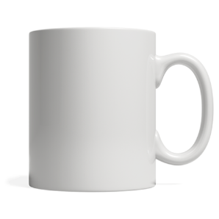
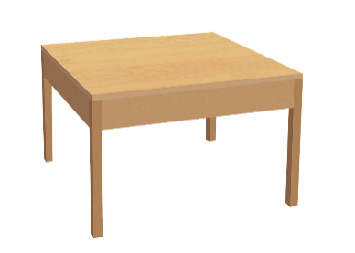

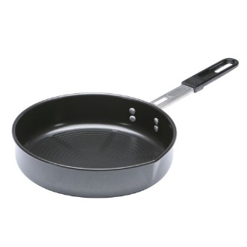
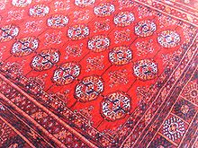
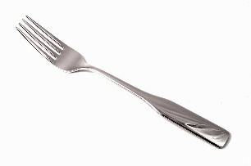

Transcript:
Number 1 is a frying pan
Number 2 is a sink
Number 3 is a table
Number 4 is a plate
Number 5 is a telephone
Number 6 is a carpet
Number 7 is a fork
Number 8 is a spoon
Number 9 is a mug

