Name: ____________________________ Surname: ____________________________ N^{ber}: ____ Grade/Class: _____
Assessment: _____________________________ | Date: ___________________________________________________
 | Teacher’s signature:  ___________________________ | Parent’s signature:  ___________________________

Listen and color the kitchen according to the instructions.
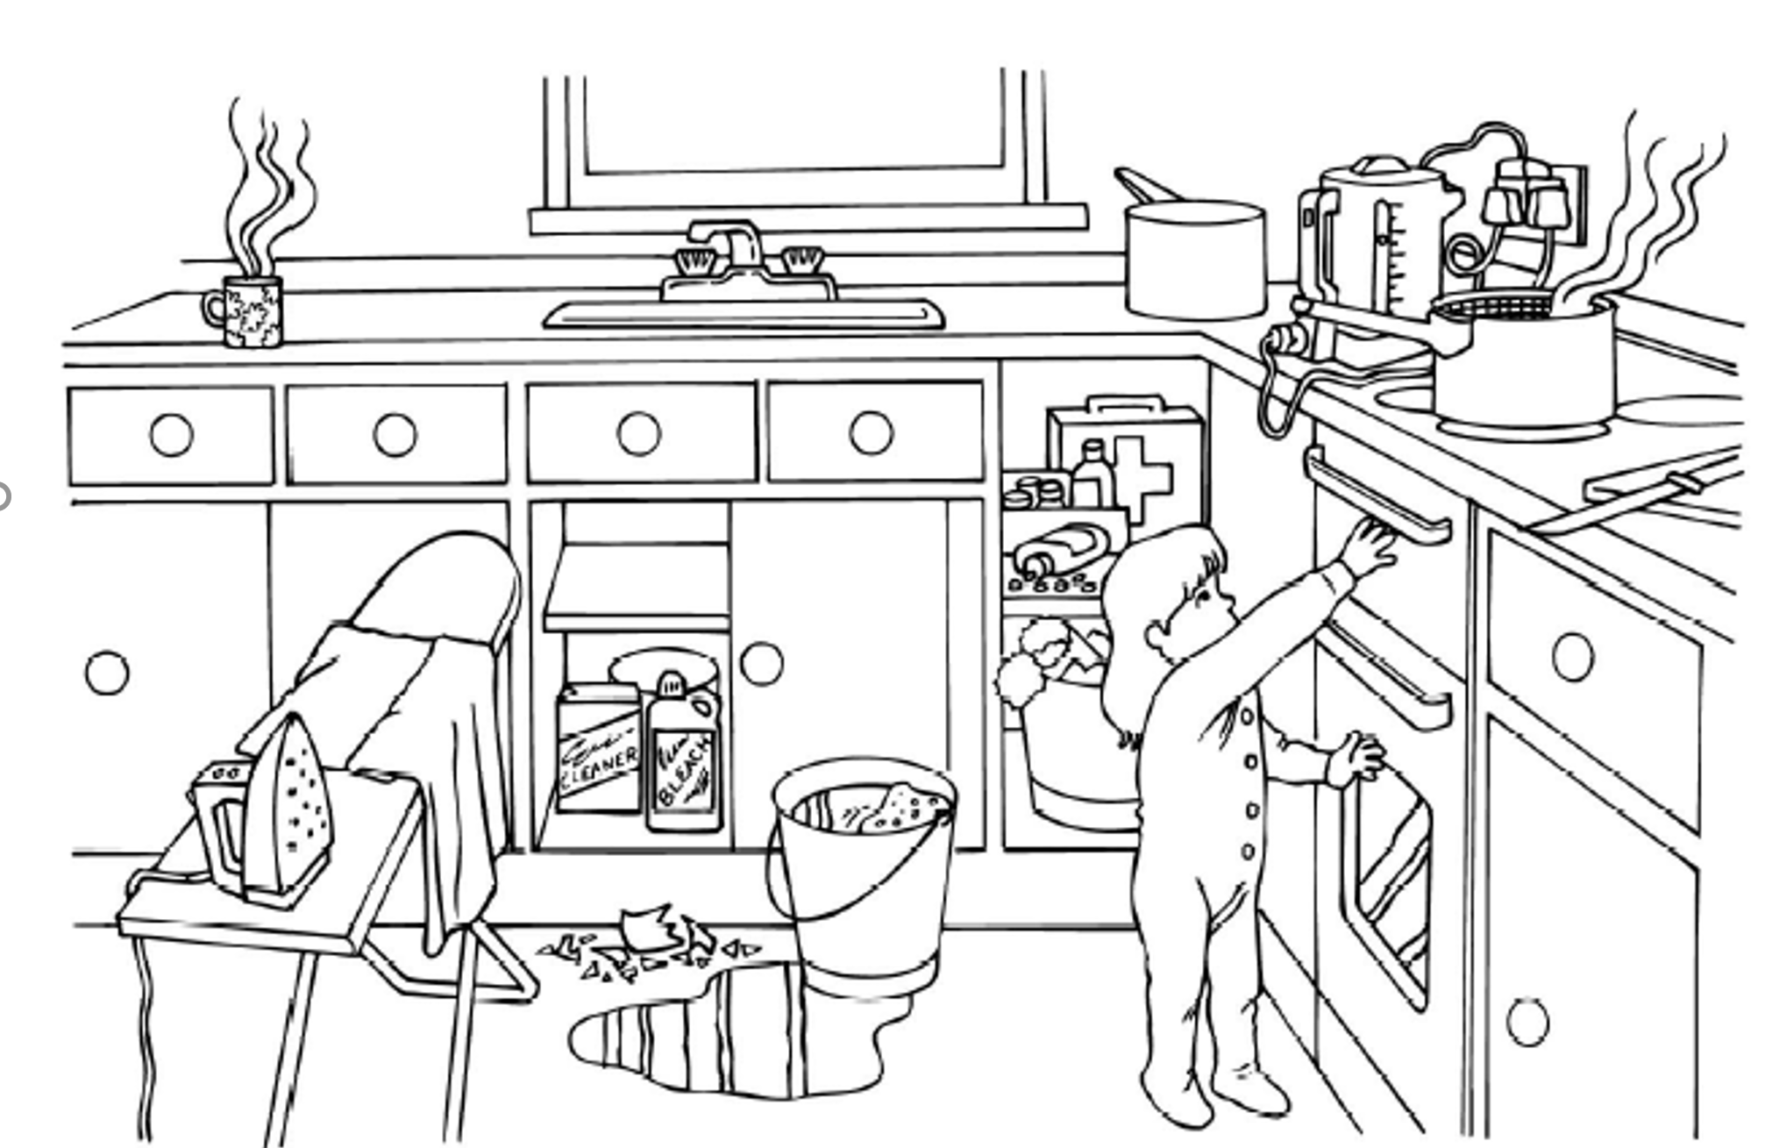

Color the girl’s hair brown.
Color the girl’s clothes purple.
Color the water on the floor blue.
Color the bucket red.
Color the tap gray.
Color the window grey.
Color the mug orange.

