Name: ____________________________ Surname: ____________________________ N^{ber}: ____ Grade/Class: _____
Assessment: _____________________________ | Date: ___________________________________________________
 | Teacher’s signature:  ___________________________ | Parent’s signature:  ___________________________

- Listen and circle the correct answer about things in the living room.
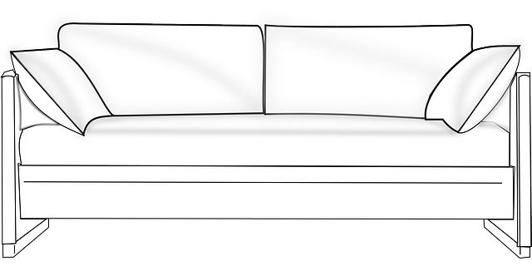

What is the sofa? The sofa is small big green

Is which room is the sofa? In the dining room In the bedroom In the living room

What colour is the sofa? Purple Red Brown

Where is the TV? On the floor On the wall On the bench

How many paintings are there? Two Three Four

Where is the coffee table? Behind the sofa Beside the sofa In front of the sofa

- Colour the sofa in the color according to the instructions.

Transcript 1:
The sofa is big.
The sofa is in the dining room.
The sofa is purple.
There is a TV on the bench.
There are three paintings on the wall.
There is a coffee table beside the sofa.

Transcript 2:
Colour the sofa blue.

