Name: ____________________________ Surname: ____________________________ N^{ber}: ____ Grade/Class: _____
Assessment: _____________________________ | Date: ___________________________________________________
 | Teacher’s signature:  ___________________________ | Parent’s signature:  ___________________________
Listen, and tick for right and for wrong.
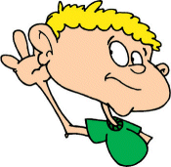

- There is a big painting in the living room.

- There are seven chairs in the dining room.

- There is a yellow pillow on the bed.

- There are many cups in the kitchen cupboard.

- There are three rugs in the hallway.

- There is a black car in the garage.

- There are five toothbrushes in the bathroom.

- There is a cat in the yard.

- There is a big table in the dining room.

- There is a bedside table in the living room.

Transcript:
- There is a big painting in the living room.

- There are six chairs in the dining room.

- There is a green pillow on the bed.

- There are many cups in the kitchen cupboard.

- There are two rugs in the hallway.

- There is a black motorcycle in the garage.

- There are five toothbrushes in the bathroom.

- There is a cat in the yard.

- There is a small table in the dining room.

- There is a bedside table in the bedroom.

