Name: ____________________________ Surname: ____________________________ N^{ber}: ____ Grade/Class: _____
Assessment: _____________________________  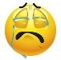  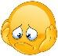  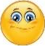  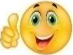  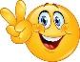 | Date: ___________________________________________________
 | Teacher’s signature:  ___________________________ | Parent’s signature:  ___________________________

Items in the wrong room. What items are in which room? Listen, number and draw a line to the correct picture.
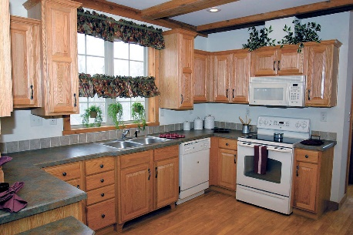
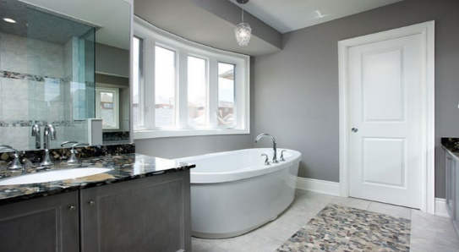
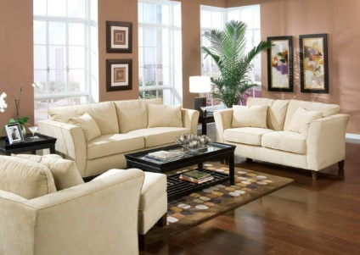

A. B. C.
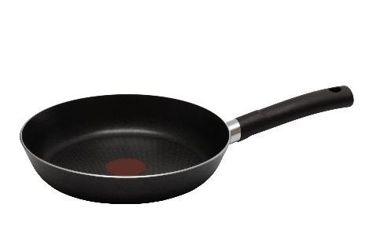
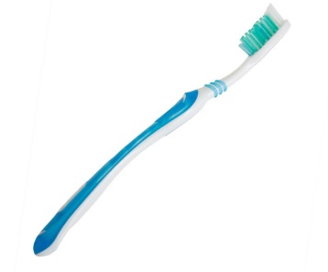
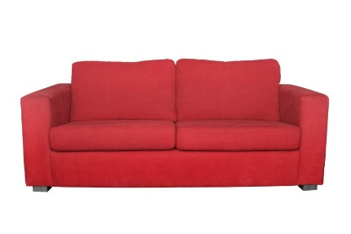

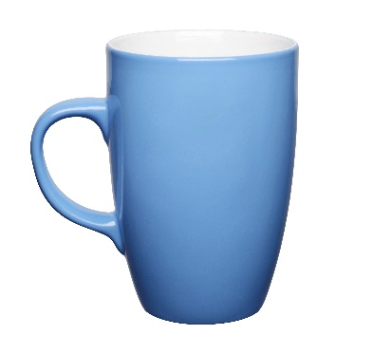
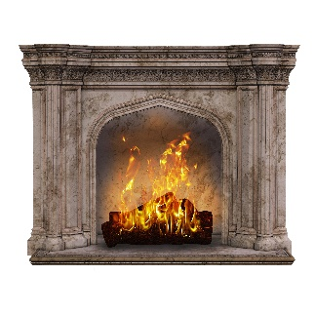
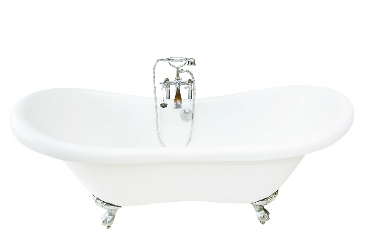

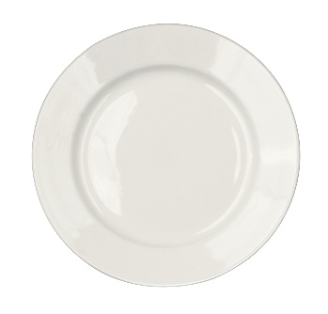
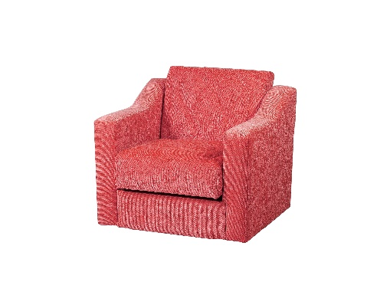
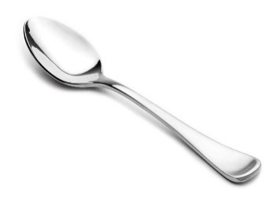

- The frying pan belongs to the bathroom.
- The bathtub belongs to the kitchen.
- The plate belongs to the living room.
- The mug belongs to the bathroom.
- The fireplace belongs to the kitchen.
- The toothbrush belongs to the living room.
- The chair belongs to the bathroom.
- The spoon belongs to the bathroom.
- The sofa belongs to the kitchen.

