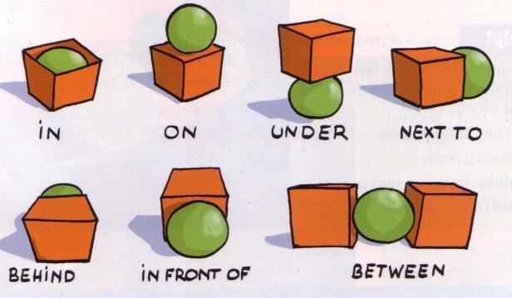
Prepositions
TOPIC: IN THE HOUSE | SUBTOPICS: PREPOSITIONS - DISCUSSION |  | LEVEL: A2
Name: Surname: |  | Nber: Grade/Class:

ENGLISH WORKSHEET

Fill in the gaps with prepositions
- the hall there is a staircase.
- the bedside table there is a lamp.
- the coffee table there is a colourful rug.
- The dining room is the kitchen.
- The French doors are the dining room.
- of the sofa there is a TV.
- the sofa and the TV is the coffee table
- the kitchen there is an oven and a stove.
- the desk is a computer.
- the bed is a bedside table.

Discussion
Tell about the house in which you live.
Have you moved house before? Tell about it.
Do you often have house guests or dinner parties? Tell about them.
Have you stayed at someone else’s house as a house guest before? Tell about it.
Have you ever looked at a house that was for sale? Tell about it. What are the best things about the home that you live in now? What are the worst things?

Assessing EFL Students

