Name: ____________________________ Surname: ____________________________ N^{ber}: ____ Grade/Class: _____
Assessment: _____________________________ | Date: ___________________________________________________
 | Teacher’s signature:  ___________________________ | Parent’s signature:  ___________________________
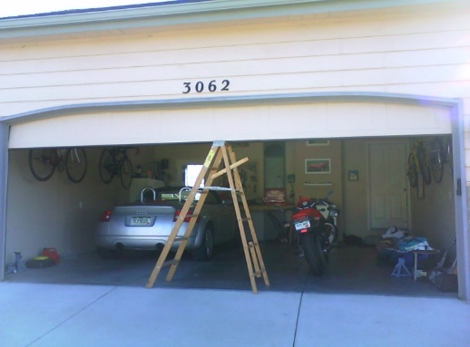
- Read the text and answer the questions.

In the garage.
Our house has a garage. The garage is big. The walls are gray. The floor is not clean. It is dirty. There are shelves on the wall. The garage has 2 doors. One door to drive the car into the garage and one door to go into the house. There is a white car in the garage. There is also a motorcycle. There is a big ladder. There are some cans of paint and five paint brushes. There is also a refrigerator.

Is the garage big or small? _____________________________________________________________
What color is the wall? _____________________________________________________________
What color is the car? _____________________________________________________________

- Choose the correct answer
Is the floor clean? Yes / No
How many cars are in the garage? One / Two
How many paint brushes are there? Four / Five

- Draw a motorcycle

