Name: ____________________________ Surname: ____________________________ N^{ber}: ____ Grade/Class: _____
Assessment: _____________________________ | Date: ___________________________________________________
 | Teacher’s signature:  ___________________________ | Parent’s signature:  ___________________________

- Read the text and answer the questions.
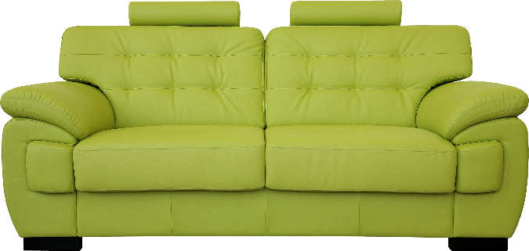
The living room.
In the living room there is a green sofa and a round blue and white carpet on the floor in front of the sofa. There are two red pillows on the sofa. There is a beautiful fireplace in the living room. There is also a table and four chairs. The chairs are white and the table is green. There are five paintings on the wall. There is a big TV on the wall in the living room. The cat likes to sleep on the carpet. The children like to play games at the table. The dog likes to lay in front of the fireplace.

What color is the sofa? ________________________________________________________
Where are the pillows? ________________________________________________________
Where does the cat like to sleep? ________________________________________________________
Where do the children like to play games? ________________________________________________________
What does the dog like to do? ________________________________________________________

- Circle the correct answer.
What color is the carpet? Blue / White
How many paintings are there on the wall? Four / Five
Is there a TV in the living room? Yes / No
Is there a fireplace in the room? Yes / No

