Name: ____________________________ Surname: ____________________________ N^{ber}: ____ Grade/Class: _____
Assessment: _____________________________ | Date: ___________________________________________________
 | Teacher’s signature:  ___________________________ | Parent’s signature:  ___________________________

Read the text and answer the questions by circling true or false.
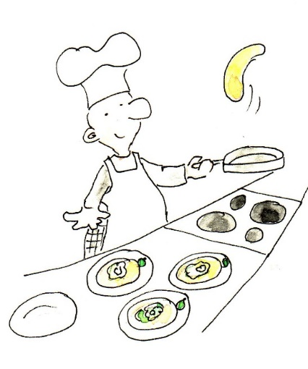
Andy is in the kitchen. Andy is cooking. He makes pancakes for breakfast. He puts the pancakes on plates and adds jam on the pancakes when they are ready.
After he eats some of the pancakes, he is bakes a chocolate cake. He needs eggs, flour, cocoa, butter and sugar. He takes out the eggs and the butter from the fridge.
The cake is in the oven, but the kitchen is very dirty. There is sugar on the floor. There are eggs on the fridge and flour on the cupboard doors.
Andy must wash the dishes and clean the kitchen. He is happy because today it is his best friend’s birthday. Her name is Anny. The cake is for her. She is thirteen today!

- Andy is making pancakes and a chocolate cake. True / False

- Any is not eating the pancakes. True / False

- He uses eggs in the cake. True / False

- The kitchen is very clean. True / False

- Andy’s best friend’s name is Anny. True / False

Key:
True
False
True
False
True

Key:
- Andy is cooking
- He is tossing the pancakes in the air.
- He needs a packet of flour
- Two dirty bowls
- No, he is happy
- 13 years old
- His best friend, Anny.
- There is sugar on the floor
- There is flour on the cupboard doors
- No, the cake is for his best friend
- He must wash the dishes and mop the floor
- Eggs and butter

