Name: ____________________________ Surname: ____________________________ N^{ber}: ____ Grade/Class: _____
Assessment: _____________________________ | Date: ___________________________________________________
 | Teacher’s signature:  ___________________________ | Parent’s signature:  ___________________________

Read the text and answer the questions with true and false.

Hello, my name is Megan and welcome to our house!
The first room is the hall. This is where we leave our jackets and shoes.
Next is the living room. I like to watch television on the sofa in the living room. The living room is very warm in the winter because it has a fireplace.
Next to the living room is the kitchen. I like to eat breakfast in the kitchen.
We have a dining room next to the kitchen. I eat dinner with my family there.
I clean my bedroom every day. It is my favourite room in the house. I have a big bed there. I like to read and have a rest in my room.
We have one bathroom. It has a bath, a shower, a sink and a toilet.
My parents have their own bedroom. They also have a TV in their bedroom.
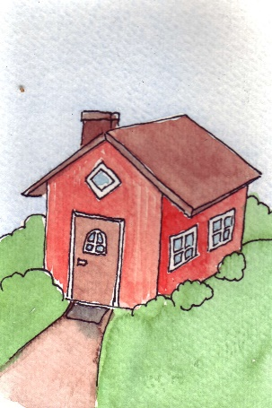

- The girl’s name is Megan. _____________
- They leave their shoes in the kitchen. _____________
- They watch TV in the living room. _____________
- There is a dining room in the house. _____________
- Megan likes to read in her bedroom. _____________
- They have two bathrooms. _____________
- They have a sofa in the bedroom. _____________

