Name: ____________________________ Surname: ____________________________ N^{ber}: ____ Grade/Class: _____
Assessment: _____________________________ | Date: ___________________________________________________
 | Teacher’s signature:  ___________________________ | Parent’s signature:  ___________________________

Read the text and answer the questions by circling the correct answer.
Tom is twelve years old. He lives in apartment with his parents, brother and sister. They live in Ottawa in Canada. They have four bedrooms, a living room, a dining room and a kitchen. They don’t have a hall. Tom’s mother is an artist. They have many of her paintings on the walls in the apartment. Tom loves the yellow sofa in the living room. He does his homework, he reads his books and watches TV there.
They don’t have a garden as they live on the second floor, but they have a balcony with a nice view over a park. They like to spend time on the balcony. In the summer they eat breakfast and dinner there.
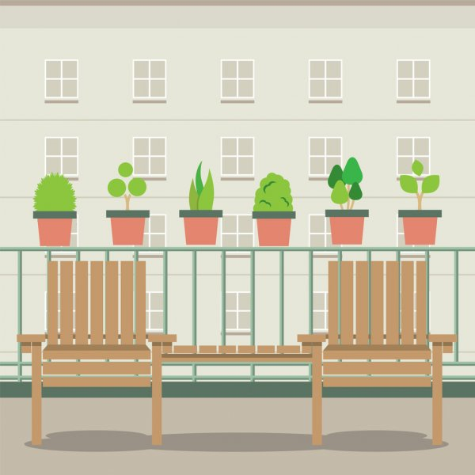
They also have a playground in the yard of the building. Tom likes to play with his friends.

1. How old is Tom? 2. Where does Tom live? 3. How many bedrooms is in Tom’s home?
- 11 a. In an apartment a. three
- 12 b. In a house b. four
- 13 c. In a tent c. two

4. What is on the wall? 5. Do they have a garden? 6. Do they have a balcony?
a. Clocks a. Yes a. Yes
b. Paintings b. No b. No
c. Lamps

