Name: ____________________________ Surname: ____________________________ N^{ber}: ____ Grade/Class: _____
Assessment: _____________________________ | Date: ___________________________________________________
 | Teacher’s signature:  ___________________________ | Parent’s signature:  ___________________________

Read the sentences and circle yes or no.

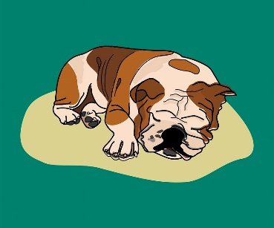
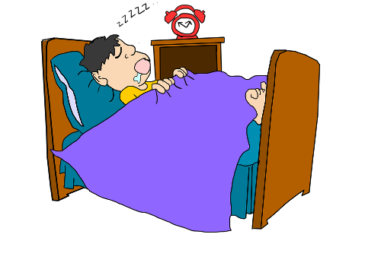
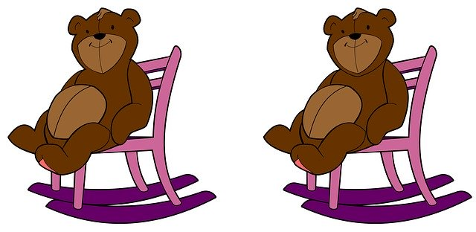

There are two brown bears sitting There is a man sleeping on the The dog is sleeping on the rug.
on pink and purple chairs. brown sofa.
YES / NO YES / NO YES / NO

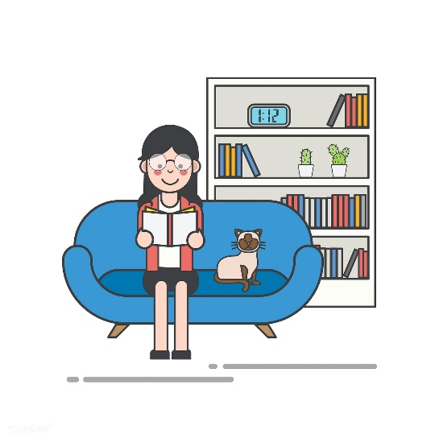
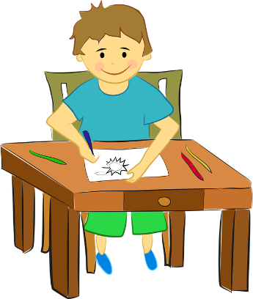
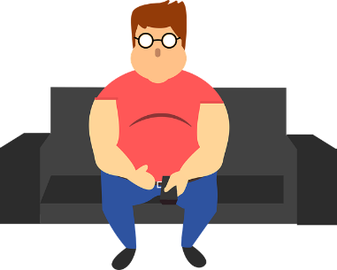

The girl is reading a book The boy is drawing and sitting The man is sitting on a black
on the bed. by the table. sofa
YES / NO YES / NO YES / NO

