Name: ____________________________ Surname: ____________________________ N^{ber}: ____ Grade/Class: _____
Assessment: _____________________________ | Date: ___________________________________________________
 | Teacher’s signature:  ___________________________ | Parent’s signature:  ___________________________

STUDENT A

- Ask your partner: “Is there a … in your room?” Answer with yes there is… / no there isn’t
- Ask how many of the items they have in their home.
Put a tick ( ) or a cross ( ).

 | 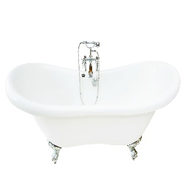 | 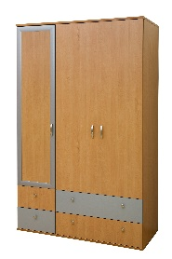 | 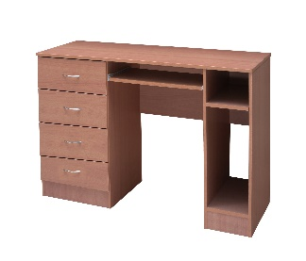 | 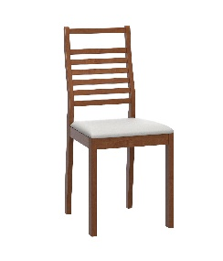 | 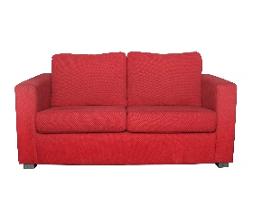 | 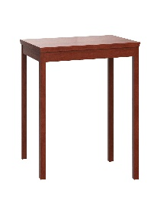
My partner’s answers

3. Answer your partner’s questions

Name: ____________________________ Surname: ____________________________ N^{ber}: ____ Grade/Class: _____
Assessment: _____________________________ | Date: ___________________________________________________
 | Teacher’s signature:  ___________________________ | Parent’s signature:  ___________________________

STUDENT B

- Ask your partner: “Is there a … in your room?” Answer with yes there is… / no there isn’t
- Ask how many of the items they have in their home.
Put a tick ( ) or a cross ( ).

 |  | 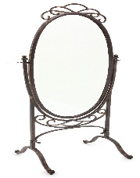 | 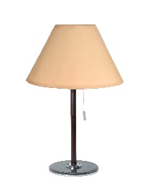 |  | 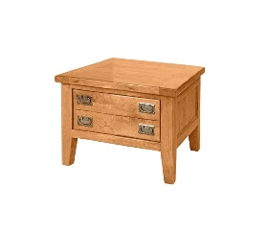 | 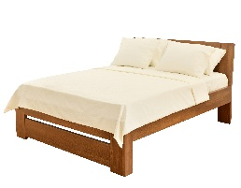
My partner’s answers | 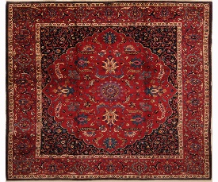

- Answer your partners’ questions.

