Name: ____________________________ Surname: ____________________________ N^{ber}: ____ Grade/Class: _____
Assessment: _____________________________ | Date: ___________________________________________________
 | Teacher’s signature:  ___________________________ | Parent’s signature:  ___________________________
Look at the pictures and make a sentence. Answer for you and for your friend Anna.
Example: I have two dolls. Anna doesn’t have two dolls. 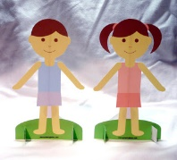
YOU ANNA
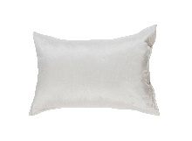 + 4
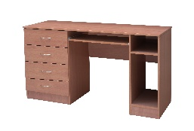+ 1
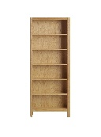+ 2
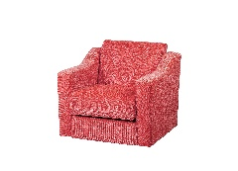+ 3
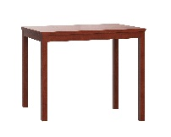+ 2
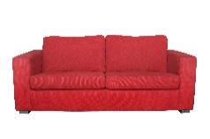+ 1
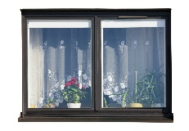+ 6

