Name: ____________________________ Surname: ____________________________ N^{ber}: ____ Grade/Class: _____
Assessment: _____________________________ | Date: ___________________________________________________
 | Teacher’s signature:  ___________________________ | Parent’s signature:  ___________________________

STUDENT A

- Answer your partners’ questions.

- Ask your partner: “Is there a/an … in your home?”
Put a tick ( ) or a cross ( ).

 | 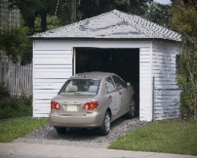 | 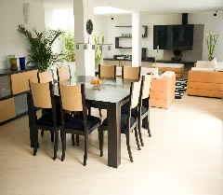 | 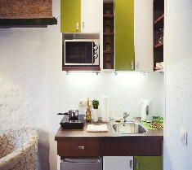 |  | 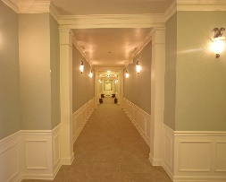 | 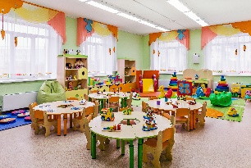
My partner’s answers

Name: ____________________________ Surname: ____________________________ N^{ber}: ____ Grade/Class: _____
Assessment: _____________________________ | Date: ___________________________________________________
 | Teacher’s signature:  ___________________________ | Parent’s signature:  ___________________________

STUDENT B

- Ask your partner: “Is there a/an … in your home?”
Put a tick ( ) or a cross ( ).

 |  | 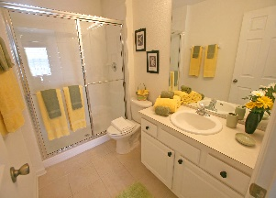 | 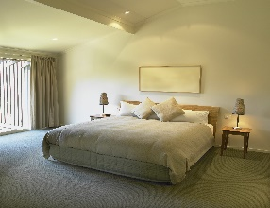 |  | 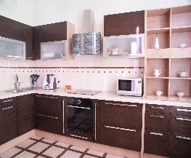 | 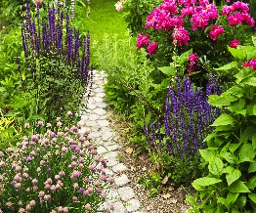
My partner’s answers

- Answer your partners’ questions.

