Name: ____________________________ Surname: ____________________________ N^{ber}: ____ Grade/Class: _____
Assessment: _____________________________ | Date: ___________________________________________________
 | Teacher’s signature:  ___________________________ | Parent’s signature:  ___________________________
Look at the pictures and make sentences.
Example: They love the rug.
= like/likes = love/loves = don’t/doesn’t like = hate/hates

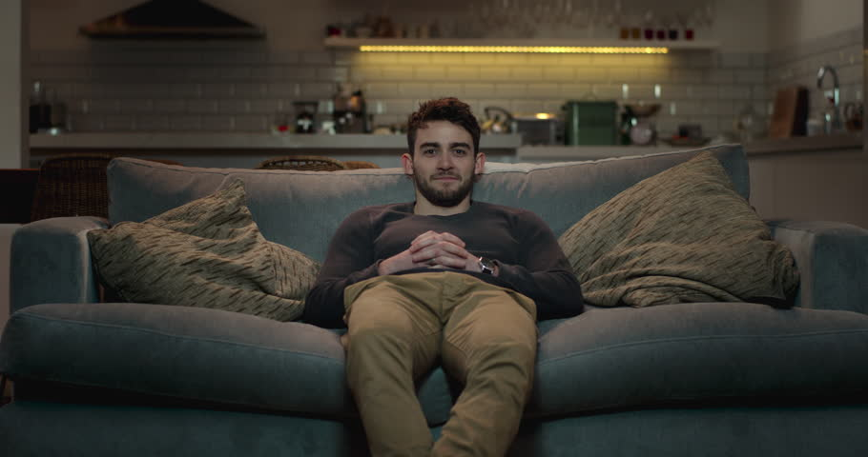
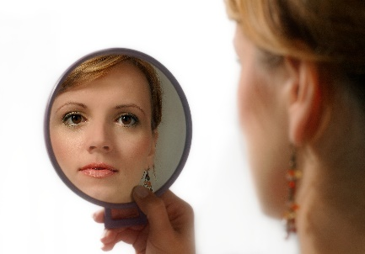
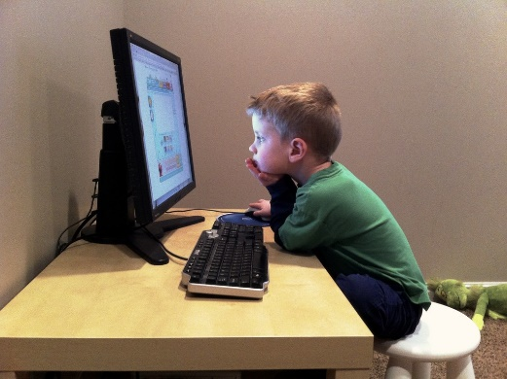
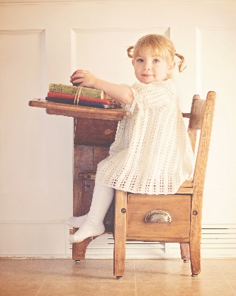
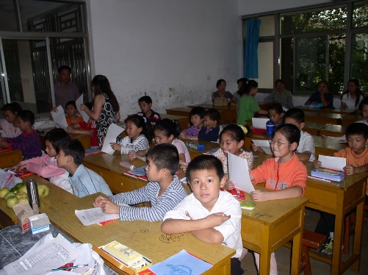

What is your favourite thing in your room?
What is your favourite thing in the house?
Which room do you like the best?

Key:

They love the rug.
She likes the mirror.
He hates the sofa.
She doesn’t like the chair.
They hate the desks.
He loves the computer.

