Name: ____________________________ Surname: ____________________________ N^{ber}: ____ Grade/Class: _____
Assessment: _____________________________ | Date: ___________________________________________________
 | Teacher’s signature:  ___________________________ | Parent’s signature:  ___________________________

Student A
In pairs, talk about the room and the items you see. Identify the room and find the differences in the pictures.
Example: Student A. There is a blue lamp in my picture Student B. There is a grey lamp in my picture.

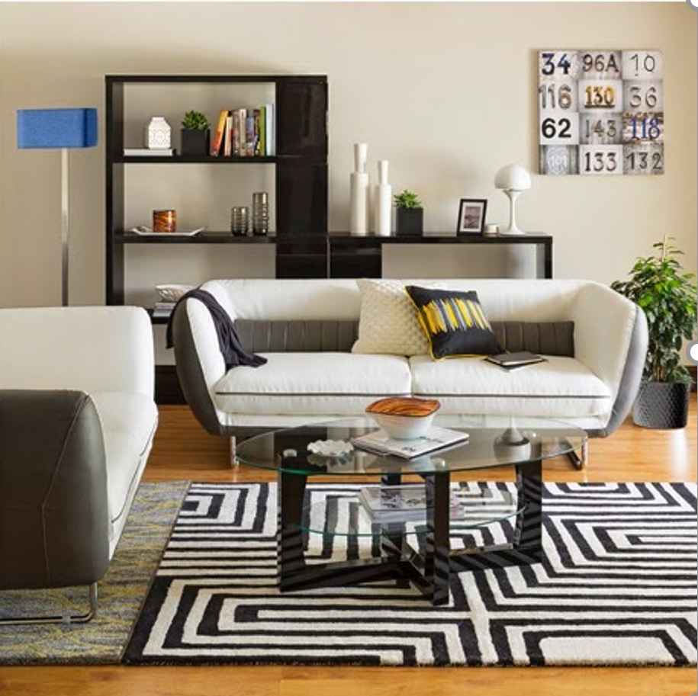

Student B
In pairs, talk about the room and the items you see. Identify the room and find the differences in the pictures.
Example: Student A. There is a blue lamp in my picture Student B. There is a grey lamp in my picture.

