Name: ____________________________ Surname: ____________________________ N^{ber}: ____ Grade/Class: _____
Assessment: _____________________________ | Date: ___________________________________________________
 | Teacher’s signature:  ___________________________ | Parent’s signature:  ___________________________

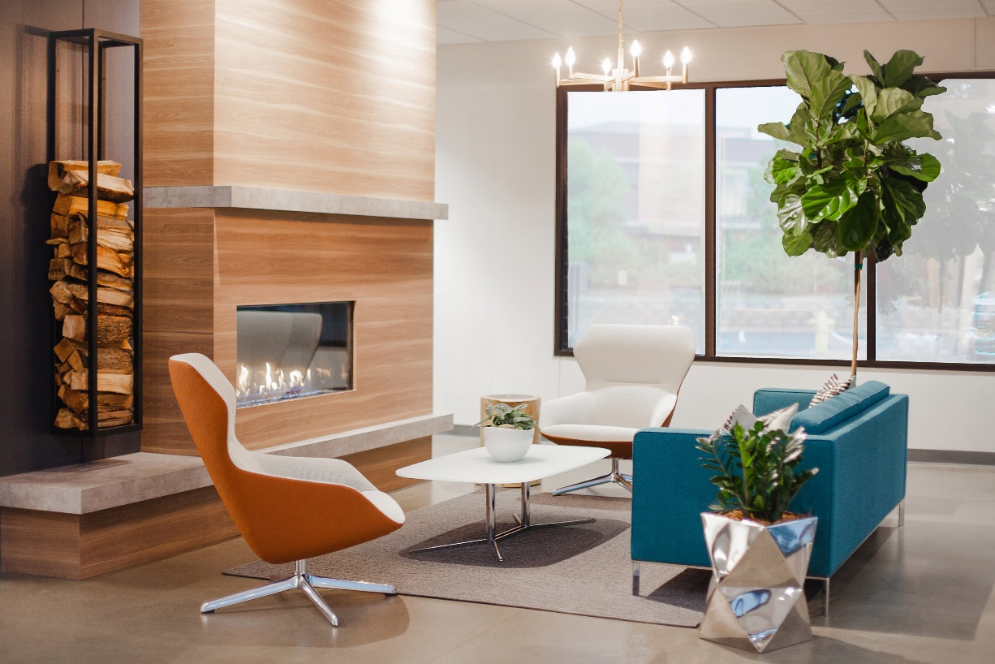
In pairs, talk about the room and the items you see. Describe the items and identify the room.
Items: Floor, fireplace, table, carpet, chair, sofa, wall, window, plant, firewood, lamp, ceiling
Use sentences like a) Where is…. b) How many…. c) What color….
Example:
Questions: 1. How many chairs are there? 2. What color are the chairs?
Answers: In the picture, I see two chairs. The chairs are white and orange.

