Name: ____________________________ Surname: ____________________________ N^{ber}: ____ Grade/Class: _____
Assessment: _____________________________ | Date: ___________________________________________________
 | Teacher’s signature:  ___________________________ | Parent’s signature:  ___________________________

Describe what you see in the room.
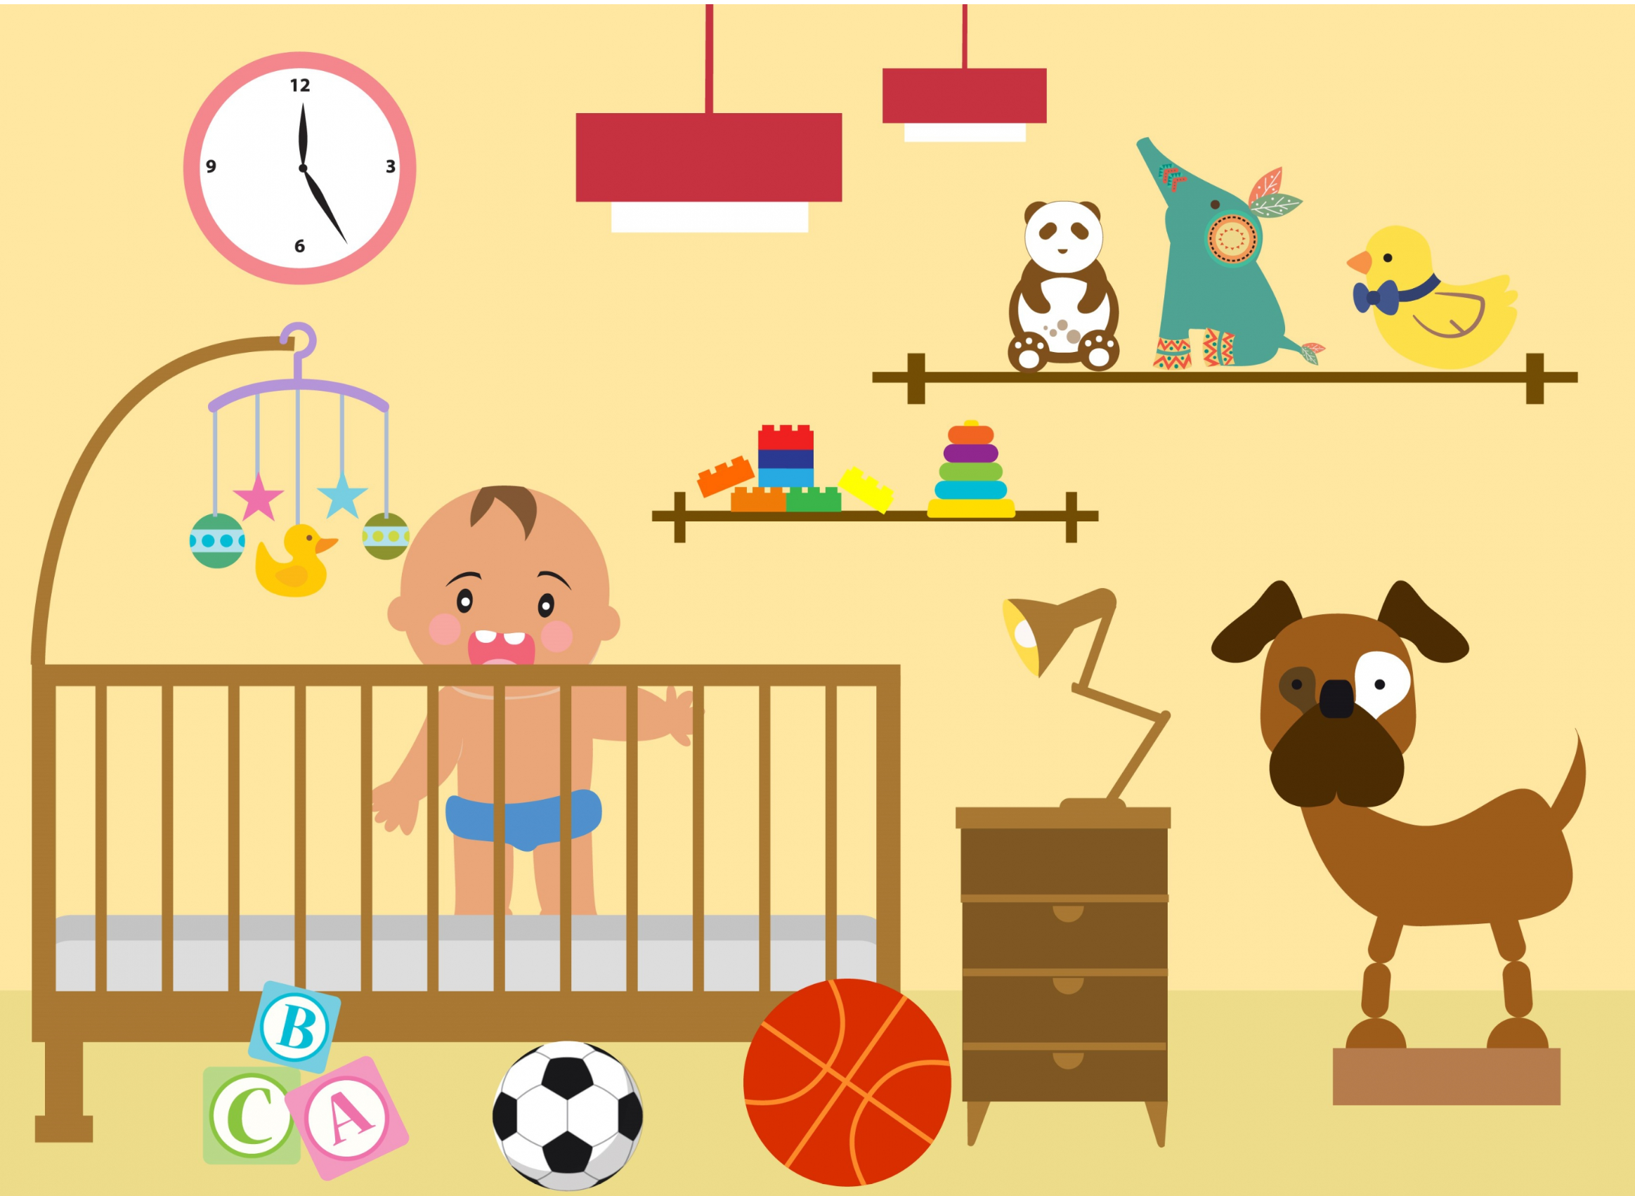

What room is this? Where is the child?
How many toys are there? How many lamps are there in the room?
What color are the toys? What is the child wearing?
What toys can you see? What animals can you see in the picture?

