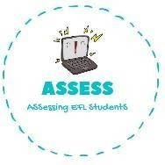
ENGLISH WORKSHEET

TOPIC: In the house | SUBTOPICS: True or false | LEVEL: A2
Name: Surname: N^{ber}: Grade/Class:

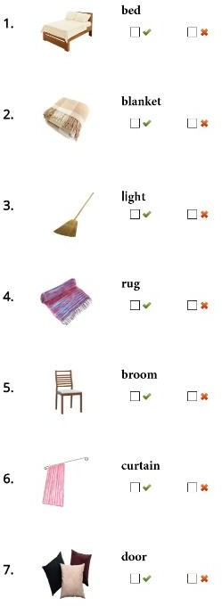
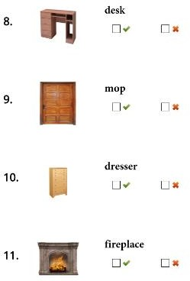
Assessing EFL Students

