Name: ____________________________ Surname: ____________________________ N^{ber}: ____ Grade/Class: _____
Assessment: _____________________________ | Date: ___________________________________________________
 | Teacher’s signature:  ___________________________ | Parent’s signature:  ___________________________

- Read and fill in the blanks.
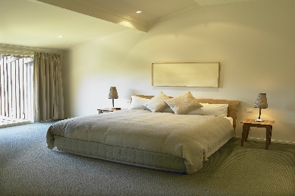
The bedroom has a big _________

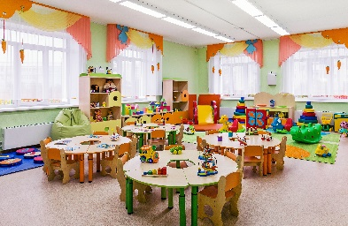

The playroom has got a lot of ________

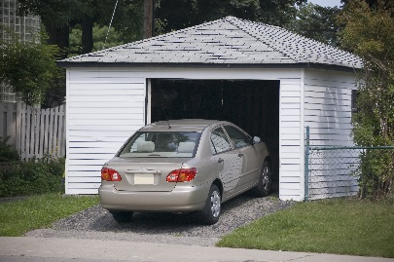

The garage is painted __________

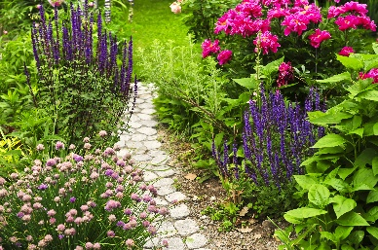
The garden has a lot of _________

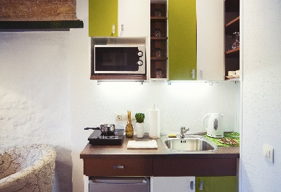
The kitchen has a __________

Answer key:
- Bed
- Toys
- White
- Flowers
- Microwave oven

