Name: ____________________________ Surname: ____________________________ N^{ber}: ____ Grade/Class: _____
Assessment: _____________________________ | Date: ___________________________________________________
 | Teacher’s signature:  ___________________________ | Parent’s signature:  ___________________________

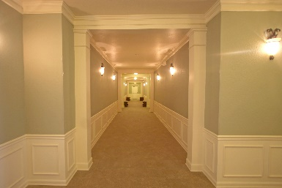
- Read and fill in the blanks.

The hallway has _______wallpaper

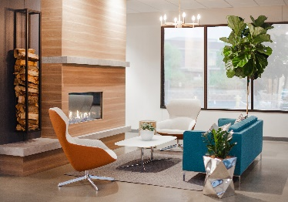

The living room has a big ________

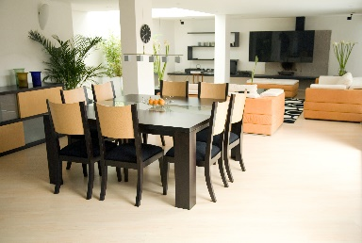
The dining room has 8 ________

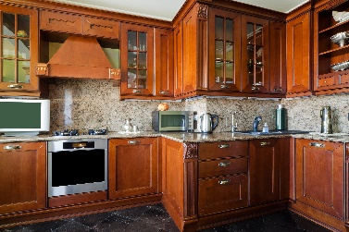

The kitchen has a silver________

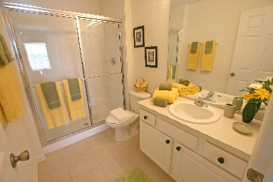

The bathroom has a_______

Answer key:
- Green
- Fireplace
- Chairs
- Oven
- Shower

