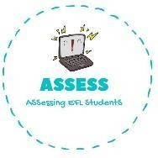
ENGLISH WORKSHEET

TOPIC: In the house | SUBTOPICS: Crossword | LEVEL: A2
Name: Surname: N^{ber}: Grade/Class:

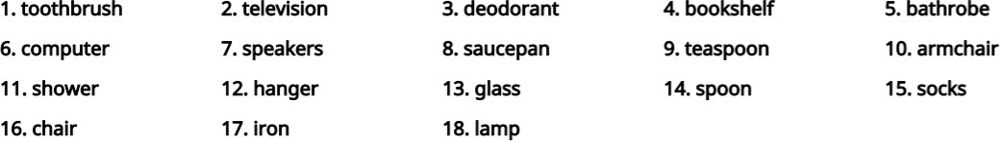

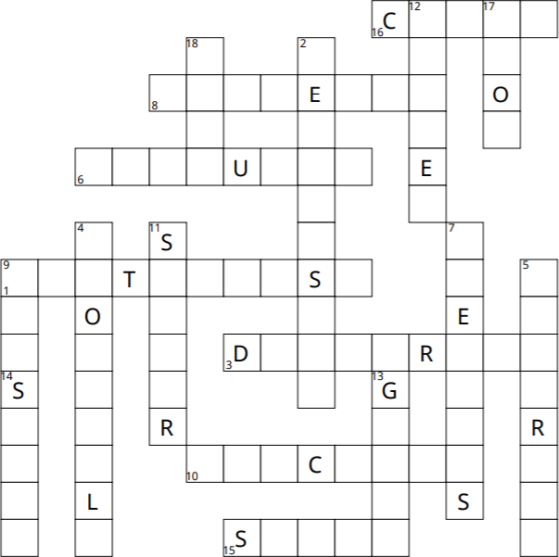

Assessing EFL Students

