Name: ____________________________ Surname: ____________________________ N^{ber}: ____ Grade/Class: _____
Assessment: _____________________________ | Date: ___________________________________________________
 | Teacher’s signature:  ___________________________ | Parent’s signature:  ___________________________

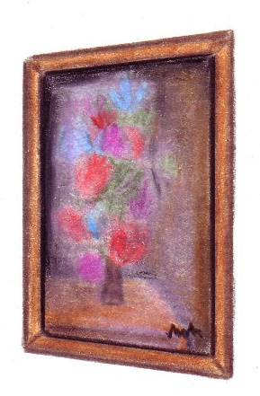
Circle the correct item.
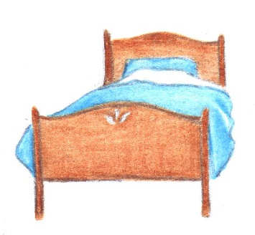
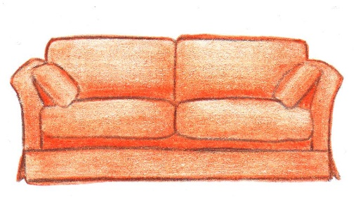
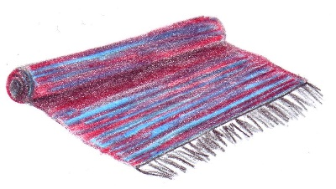

Chair Rug Bookcase Sofa
Wardrobe Sofa Wardrobe Bed
Bed Table Painting Chair
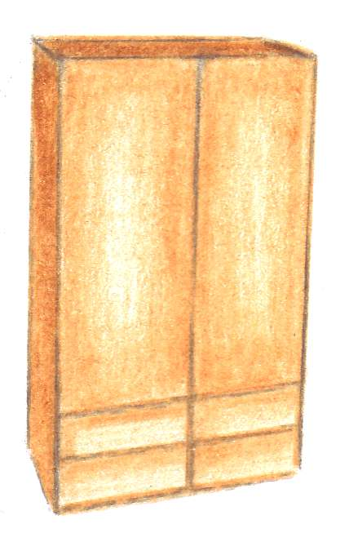
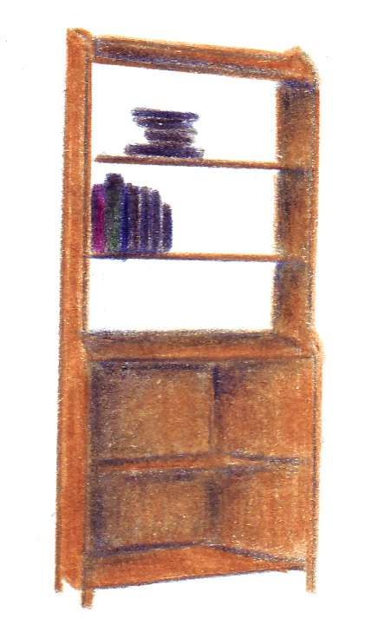
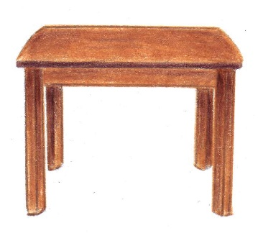
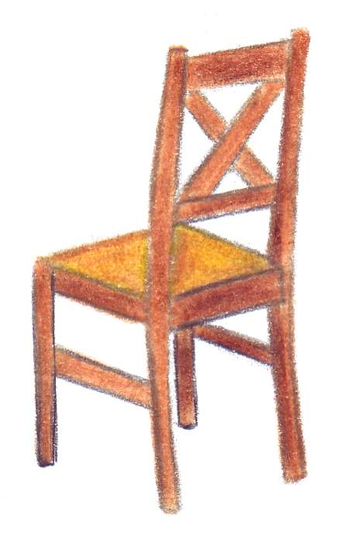

Bed Table Chair Wardrobe
Painting Wardrobe Bookcase Sofa
Chair Sofa Rug Bed

