Name: ____________________________ Surname: ____________________________ N^{ber}: ____ Grade/Class: _____
Assessment: _____________________________ | Date: ___________________________________________________
 | Teacher’s signature:  ___________________________ | Parent’s signature:  ___________________________

Fill in the gaps and match the items with the correct room.

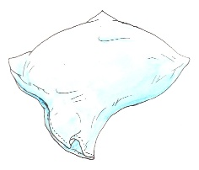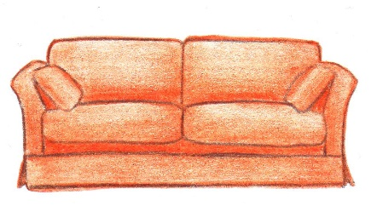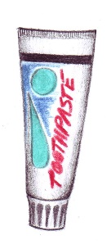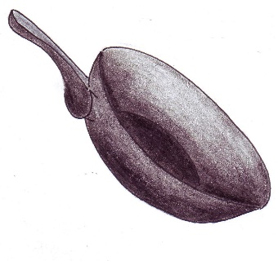

S _ _ A
T _ _ _ H _ _ _ _ E
P_ _ _ w
F _ _ I _ _ P _ N
T_ W_ _
K _ _ _ _
C _ F F _ _ T _ B _ E

Living room Bedroom Kitchen Bathroom

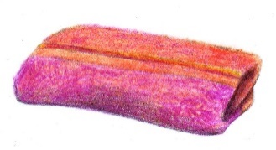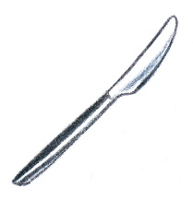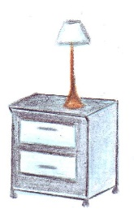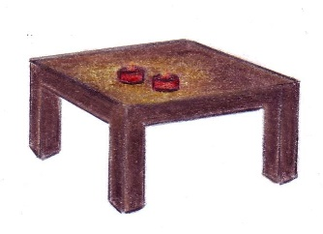
B _ _ S _ D _ T _ _ _ E

Key:
Pillow
Sofa
Toothpaste
Fryingpan
Towel
Knife
Bedside table
Coffee table

