Name: ____________________________ Surname: ____________________________ N^{ber}: ____ Grade/Class: _____
Assessment: _____________________________  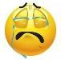  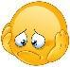  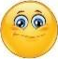 | Date: ___________________________________________________
 | Teacher’s signature:  ___________________________ | Parent’s signature:  ___________________________

Fill in the missing words, choose from the pictures.
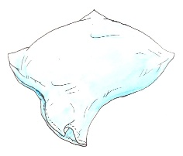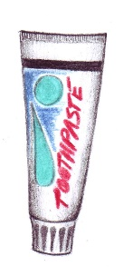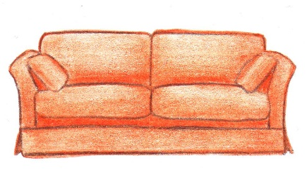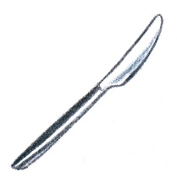

- You put your head on a _ _ _ _ _ _ at night.
- You sit on the _ _ _ _ when you watch TV.
- Before you go to bed, you use a toothbrush and _ _ _ _ _ _ _ _.
- When you need to fry something, you use a _ _ _ _ _ _ _ _ _.
- After your shower, you dry yourself with a _ _ _ _ _ .
- You cut your food with a _ _ _ _ _.
- The _ _ _ _ _ _ _ _ _ _ is next to your bed.
- A _ _ _ _ _ _ _ _ _ _ is often near the sofa.

