Name: ____________________________ Surname: ____________________________ N^{ber}: ____ Grade/Class: _____
Assessment: _____________________________  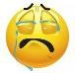  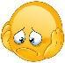  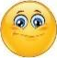  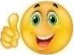  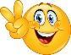 | Date: ___________________________________________________
 | Teacher’s signature:  ___________________________ | Parent’s signature:  ___________________________

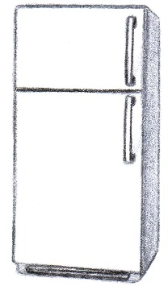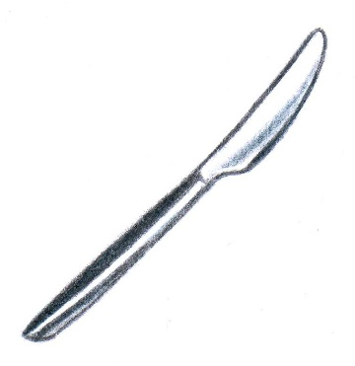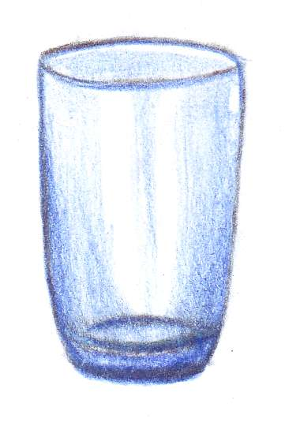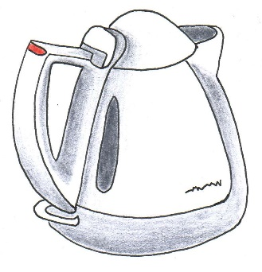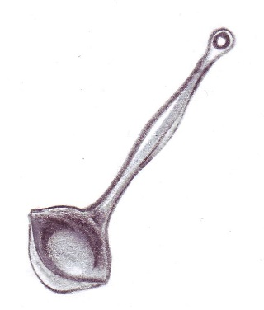
Answer the questions about items in the kitchen and draw a line to the correct picture.
- What do you use if you want to fry an egg? You use a _ _ Y _ _ _ P _ _
- What do you use if you want to boil some water? You use a K _ _ T _ E
- What do you use when you want to put food onto something? You use a _ L _ _ E
- What do you serve soup with? You serve soup with a L _ D _ E
- If you want to make a soup, what do you use? You use a S _ U C _ P _ N to make soup.
- Where do you keep your food cool? You keep your food cool in a R _ F R _ _ _ R _ _ O R
- If you are thirsty, where do you pour your drink? You pour your drink into a _ L _ _ S
- When you want to cut a piece of your food, what do you use? You use a K _ _ F _ to cut your food
- If you want to have some tea, what do you use? You use a M _ _ if you want to drink some tea.
- If you want to wash your dishes, where do you put them? You put the dishes in a S _ N _

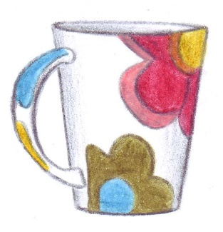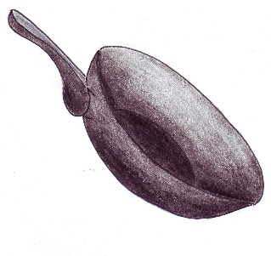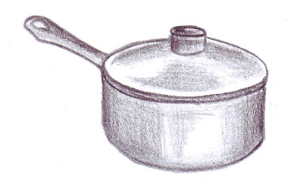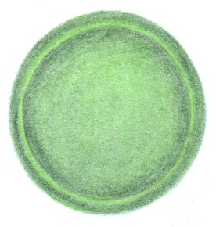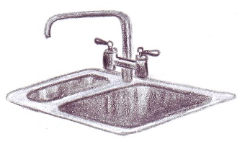

Key:
- Frying pan
- Kettle
- Plate
- Ladle
- Saucepan
- Refrigerator
- Glass
- Knife
- Mug
- Sink

