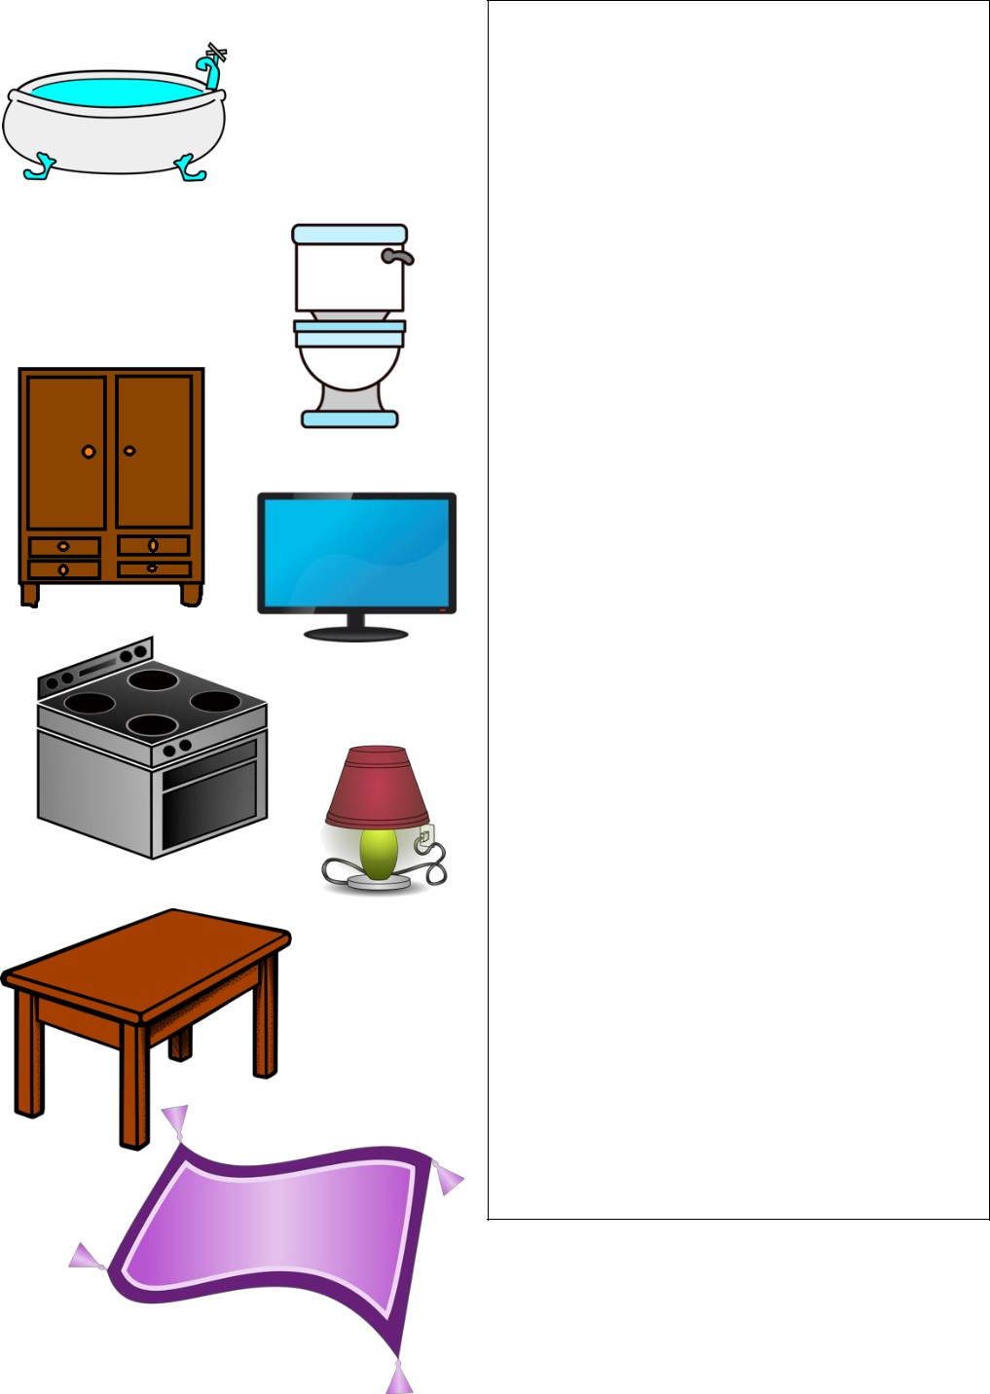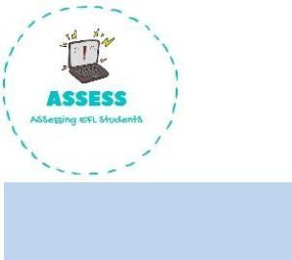

**Match the word to the picture**

|  |  |  |  |
| --- | --- | --- | --- |
| **TOPIC: IN THE HOUSE** | **SUBTOPICS: VOCABULARY** | | **LEVEL: A2** |
| **Name: Surname:** | | **Nber: Grade/Class:** | |

**ENGLISH WORKSHEET**

Bath Shower Toilet Bed

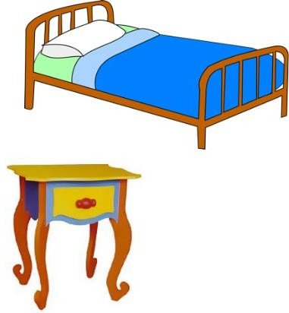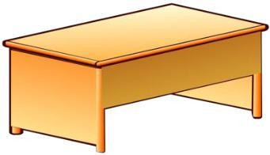

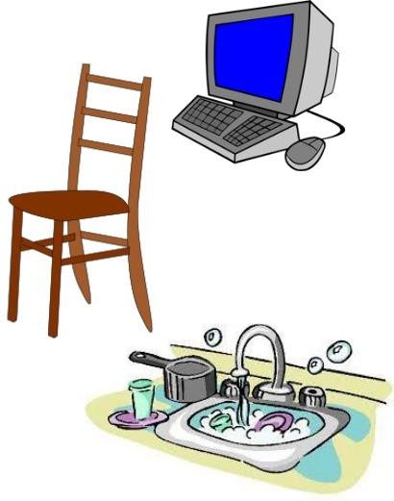Bedside table Lamp Wardrobe Desk Computer

Oven and stove Sink

Dining table Chair Sofa Rug

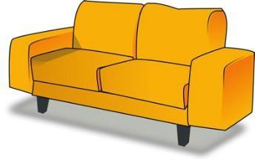TV

Assessing EFL Students