Name: ____________________________ Surname: ____________________________ N^{ber}: ____ Grade/Class: _____
Assessment: _____________________________ | Date: ___________________________________________________
 | Teacher’s signature:  ___________________________ | Parent’s signature:  ___________________________
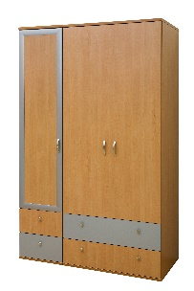
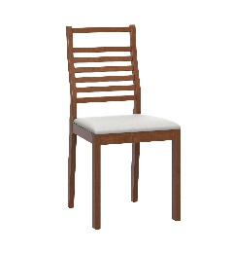
- Write and match.
- R__g
- Mi__r__r
- La__p
- C__m__u__er
- B__d
- W__r__ro__e
- De__k
- B__d__ide T__b__e
- C__a__r
- So__a
- Ba__h
- Ta__le

