Name: ____________________________ Surname: ____________________________ N^{ber}: ____ Grade/Class: _____
Assessment: _____________________________ | Date: ___________________________________________________
 | Teacher’s signature:  ___________________________ | Parent’s signature:  ___________________________

Look at the picture of the bedroom and fill in the missing words.
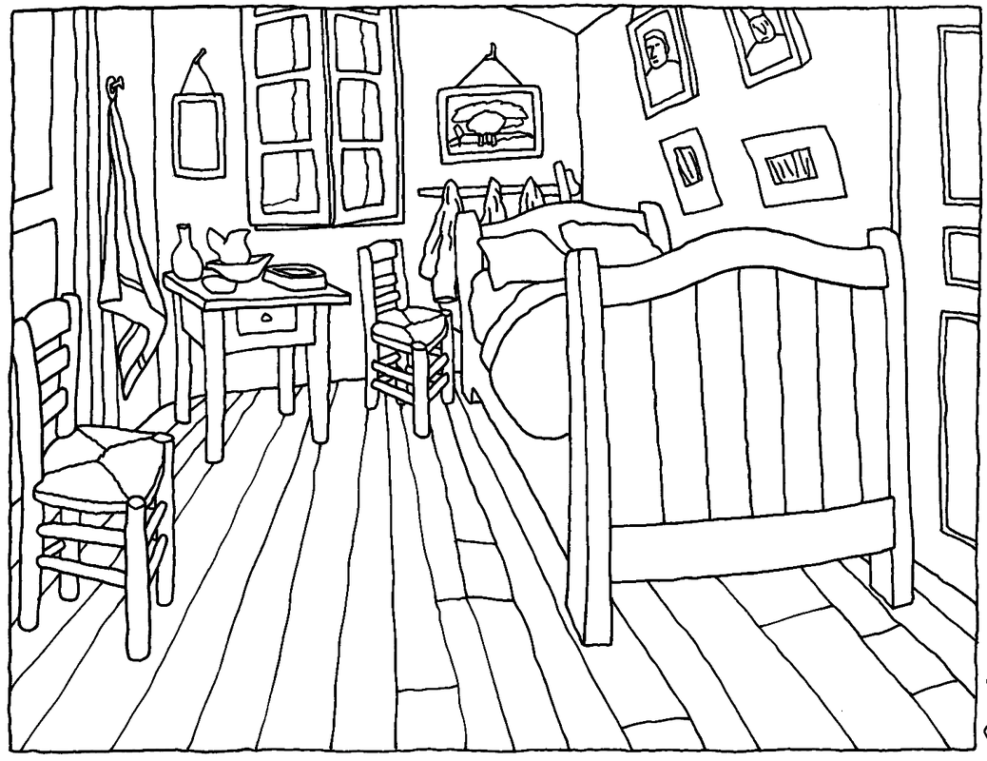

1. This is my _______________________.
2. My _______________________ is in the corner.
3. Near the bed, there is a _______________________.
4. There are many _______________________ on the wall.
5. There are two _______________________ in my bedroom.
6. In my bed, I have two _______________________.

Key:
1. This is my bedroom.
2. My bed is in the corner
3. Near the bed, there is a bedside table.
4. There are many pictures/paintings on the wall.
5. There are two chairs in my bedroom.
6. In my bed I have two pillows.

