Name: ____________________________ Surname: ____________________________ N^{ber}: ____ Grade/Class: _____
Assessment: _____________________________ | Date: ___________________________________________________
 | Teacher’s signature:  ___________________________ | Parent’s signature:  ___________________________
Look at the pictures and write something about the them.
Example: 1. The box is small.
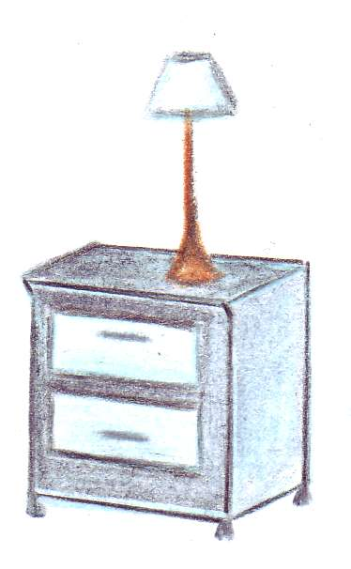
- 2. 3. 4. 5. 6.


 

 

 

 

 

