Name: ____________________________ Surname: ____________________________ N^{ber}: ____ Grade/Class: _____
Assessment: _____________________________ | Date: ___________________________________________________
 | Teacher’s signature:  ___________________________ | Parent’s signature:  ___________________________

Draw a line to the missing word and write the word in the gap.
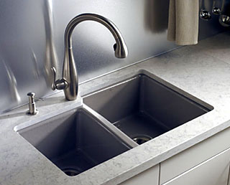

There are many _ _ _ _ _ _ in the cupboard.

There is an __ _ _ in the kitchen.

There is a _ _ _ _ _ _ _ _ on the table.

There is a _ _ _ _ _ _ on the floor.

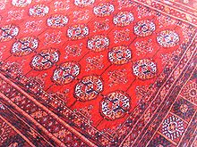
There are many mugs in the _ _ _ _ .

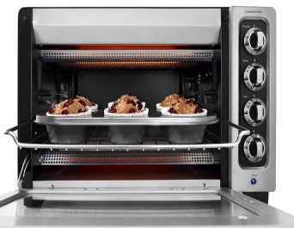

Key:
There are many plates in the cupboard.
There is an oven in the kitchen.
There is a telephone on the table.
There is a carpet on the floor.
There are many mugs in the sink.

