Name: ____________________________ Surname: ____________________________ N^{ber}: ____ Grade/Class: _____
Assessment: _____________________________ | Date: ___________________________________________________
 | Teacher’s signature:  ___________________________ | Parent’s signature:  ___________________________
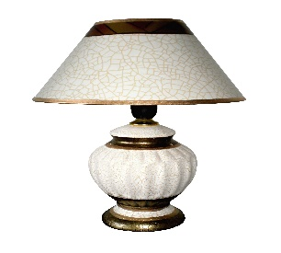
This Photo by Unknown Author is licensed under CC BY-SA
Match the two sections and write the full sentence.

A lamp gives light
A painting is
A rug is often
A sofa is where you
A table is used
A wardrobe is used
Bathtubs are
Chairs are often

can sit and watch TV
when eating dinner
next to the table
to store your clothes
when it’s dark
a picture in a frame
on the floor
in the bathroom
- ______________________________________________________________________

- ______________________________________________________________________

- ______________________________________________________________________

- ______________________________________________________________________

- ______________________________________________________________________

- ______________________________________________________________________

- ______________________________________________________________________

- ______________________________________________________________________

