Name: ____________________________ Surname: ____________________________ N^{ber}: ____ Grade/Class: _____
Assessment: _____________________________ | Date: ___________________________________________________
 | Teacher’s signature:  ___________________________ | Parent’s signature:  ___________________________
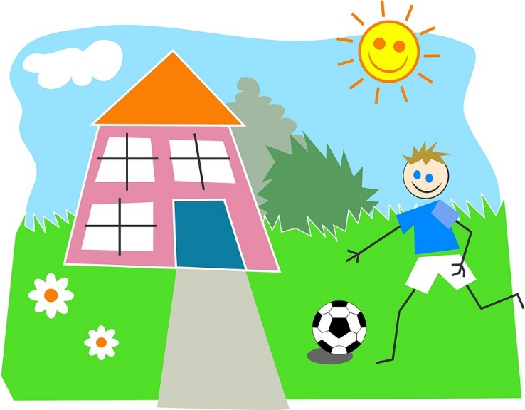

Fill in the gap with living room, kitchen, garage, garden, bathroom, bedroom, hallway, dining room

- I brush my teeth in the _______________.

- She lays on the sofa in the _______________.

- They eat in the _______________.

- I take off my shoes in the _______________.

- You play outside in the _______________.

- We keep many things in the _______________.

- He sleeps in the _______________.

- They cook in the _______________.

