Name: ____________________________ Surname: ____________________________ N^{ber}: ____ Grade/Class: _____
Assessment: _____________________________ | Date: ___________________________________________________
 | Teacher’s signature:  ___________________________ | Parent’s signature:  ___________________________

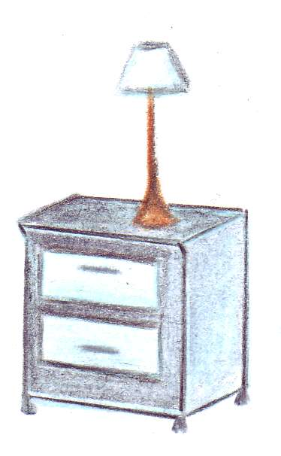
Write the words and which room you think the items belong to.
Choose from kitchen, living room, bedroom or bathroom.
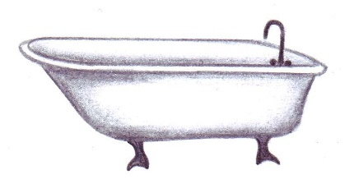

Bath _______________________ _______________________
Bathroom _______________________ _______________________


  
  

